**Project Portfolio**

**ENGIE**

**Work streams “XXX”, “YYY”, etc. in the strategic value chain**

Table of Content

1 Project Outline 4

1.1 Presentation of ENGIE and ELHySE consortium 4

1.1.1 ENGIE presentation 4

1.1.2 ELHySE project 4

1.2 Objectives of ENGIE in the IPCEI in all technical fields it is involved 6

1.2.1 Context of hydrogen market and mobility decarbonization 6

1.2.2 Objectives of the project 8

1.2.3 Roadmap 8

1.2.4 Preliminary planning 9

1.3 R&D Projects Before IPCEI for ENGIE 11

1.4 Technology and Challenges – R&D&I Activities within IPCEI in all technical fields it’s involved 13

1.4.1 State of the art and technical locks for LH2 liquefaction 14

✓ Kuendig et al. 19

✓ Kuzmenko et al. 19

✓ Valenti-Macchi (2008) 20

✓ Quack (2002) 21

✓ IdealHY (2013) 22

✓ Krasae-in (2014): 23

1.4.2 Objectives and technical challenges in the project 28

1.5 First Industrial Deployment (FID) 32

1.5.1 Purpose of the FID phase 32

1.5.2 Technical challenges in the FID phase 32

1.5.3 Transition from the FID phase to the mass production / commercialisation phase 37

1.5.4 Revenues in the FID phase 38

1.6 Environmental, energy or transport projects before the IPCEI 39

1.7 Importance of the project for the environmental, energy or transport strategy of the European Union 42

1.7.1 Project’s contribution to the decarbonisation of the energy sector 42

1.7.2 Project’s contribution to the European industry’s innovation and global leadership in the green economy 43

1.7.3 Project’s contribution to the rolling out of cleaner, cheaper and healthier forms of private and public transport 43

1.7.4 Project’s contribution to creating new jobs in the green economy 43

1.7.5 Other contributions to sustainable development 44

1.8 Contribution to the hydrogen strategic value chain 44

1.8.1 Project’s position in the hydrogen strategic value chain 44

1.8.2 Industrial value chain in France 44

1.8.3 Industrial value chain in Europe 45

1.9 Intellectual Property Rights 45

1.9.1 IP management principles 45

1.9.2 IP protection principles 45

1.10 Work Plan 47

1.10.3 Massification – WP5 48

1.10.4 Dissemination – WP6 48

1.11 Investments 49

Tools and Equipment 49

1.11.1 Construction of Buildings/Laboratory 50

2 Budget 52

2.1 Eligible Costs 52

2.2 State Aid 53

3 Spill-over Effects 54

3.1 Spill-over by non-protected results diffusion 54

3.2 Spill-over by IP protected results diffusion 54

3.3 Spill-over in the FID phase 55

4 Other positive effect on the market 57

4.1 Impact of the Project on Employment and New Investments in Europe 57

4.2 Environmental protection and reduction in energy dependence 57

4.3 Market failures: coordination problems 59

4.3.1 Coordination failures between companies and research organizations 59

4.3.2 Coordination failures between European research organizations themselves 60

4.3.3 Coordination failures between SMEs and industry leaders 60

4.3.4 Coordination failures between European clusters 61

4.3.5 Coordination failures of a very large-scale R&D project 61

4.3.6 Coordination failures associated with contractual incompleteness 62

4.4 Market failure: Imperfect and asymmetric information 63

4.4.1 Risks affecting the project 63

4.4.2 Market failure: Difficulty to recruit highly qualified personnel 65

4.4.3 Strategic independence of supply 66

4.5 Adequacy of the state aid instrument 66

4.5.1 Appropriateness among alternative policy instruments 66

4.5.2 Appropriateness among different State aid instruments 68

5 Incentive effect 70

6 Elaboration on Terms of the Funding Gap Questionnaire 72

6.1 Main hypothesis of the business plan 72

6.2 Necessity of state aid 73

6.3 Proportionality of state aid 73

6.3.1 Firm’s hurdle rate 73

6.3.2 Project’s funding gap 73

6.3.3 State aid intensity 74

6.3.4 State aid cumulation 74

6.3.5 Open selection proceeding 74

7 Limitation of distortion of competition and trade 75

*Annexe 1:* 76

1. Project Outline
   1. Presentation of Company and Project
      1. Company

Here

* + 1. ELHySE consortium

ENGIE, ArianeGroup and CMA CGM have launched the Elhyse project to develop the renewable and/or carbon-free liquid hydrogen supply chain for heavy-duty and long-haul transportation in France and in Europe.

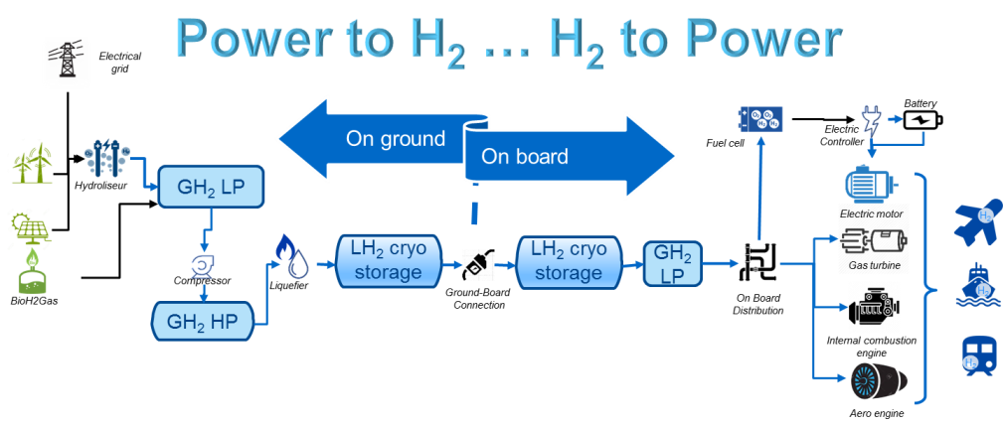

Figure 1 Renewable- carbon free Liquid hydrogen supply chain for heavy duty mobility

The partners of this project, ArianeGroup, CMA CGM and ENGIE, have the know-how, expertise, knowledge of the markets and technologies, and the necessary means to kick start this sector. They join forces in France and at European level with the players able to complete the on-ground segment (equipment manufacturers, port authorities, etc.) and the on-board segment (design offices, equipment manufacturers, integrators, shipyards, certification authorities, etc.) providing real added value and a significant impact for the competitive and large-scale development of the renewable liquid hydrogen sector. Partners will accelerate the development and industrialization of the supply of economically viable and resilient solutions as well as safe and efficient equipment.

In particular and as detailed in this application file, the objective of ENGIE is to develop with ArianeGroup and future partners (for example FivesCryo is already identified as a potential partner for heat exchanger development) a high-performance innovative solution for the liquefaction of hydrogen and demonstrate the feasibility of the LH2 value chain thanks a demonstrator project supplying a CMA CGM ship in a port. This first project of its kind in Europe will lay the foundations for developing this solution on a European scale by targeting the main ports. Thus, Europe will be able to register as a leader in the liquid hydrogen market for maritime and river mobility, thanks to French expertise, and have the opportunity to disseminate its standards on an international scale.

This project is therefore part of a national and European strategic vision of long-term re-industrialization, while offering the possibility of obtaining results in the short and medium terms.

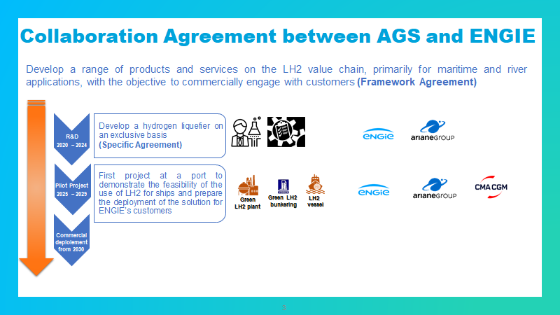

Figure 2 - ArianeGroup and ENGIE partnership scheme for liquefier development

The project promoted by ArianeGroup, CMA CGM and ENGIE is 100% aligned on the following recommendation of the final Report of the Strategic Forum for IPCEI (Strengthening Strategic Value Chains for a future-ready EU Industry, p.74): ***“Push forward the hydrogen-based inland or coastal ships and maritime vessels as an alternative to highly pollutant diesel engines (to 2025: e.g. 1 big ship order + 10 inland ships and/or other sea-going ships). Support the development of new hydrogen inland ships or costal vessels, the related infrastructure (hydrogen refueling stations) and develop a positive, stable legislative and regulatory framework.”***

* 1. Objectives of ENGIE in the IPCEI in all technical fields it is involved
     1. Context of hydrogen market and mobility decarbonization

Today, over 50 percent of the global production of hydrogen is used to produce ammonia for urea and other fertilizers. Of the remaining half, around 30 percent is used for various processes related to refineries and about ten percent is used for methanol production. Hydrogen for transporting purposes is merely a marginal market as of today. In total the current demand for hydrogen is about 8 EJ of energy per year, equivalent to about 67 million tons of hydrogen or 2224 TWh of electricity

The future global hydrogen market is dependent on both technological and political development. The International Renewable Energy Agency (IRENA) estimates an additional market demand of 8 EJ in 2050 – in addition to the current demand in feedstock. The growth will come in the transportation sector.

In a more optimistic scenario, the Hydrogen Council foresees that the hydrogen market could increase tenfold to 78 EJ in 2050. While all sectors grow, transportation makes the largest leap, from next to nothing in 2019 to approximately 22 EJ or 6116 TWh of electricity.

The transport sector is highly dependent on fossil fuels and alone accounts for more than 20% of global CO2 emissions worldwide. Maritime transport accounts for 3% of these emissions and the air transport represents 11% of these emissions. Petroleum products are overwhelmingly (90%) used for mobility. However, the authorities impose more and more ambitious roadmap for a full decarbonisation of the maritime transport sector. Here are some examples: the International Maritime Organisation (IMO) has recently made important decisions with regard to the increase of the GHG emissions from ships. ***IMO has set a 50% reduction target for emissions related to maritime transport by 2050 compared to 2008***. In France, the government announced in June 2020 its willingness to develop a full decarbonized hydrogen plane by 2035. At the same time, SNCF indicated that all diesel trains will be replaced by hydrogen trains by 2030.

Those decisions pushed the transport industrial actors to look for solutions to use sustainable energy sources and lower harmful emissions. In June 2020, CMA CGM committed for a more balanced globalization, which contributes to Economic and Social development, whilst respecting humanity and protecting the planet. CMA CGM announced at this occasion that their energy supplies will include 10% alternative fuels by 2023 and their 2050 objective is to be Carbon Neutral.

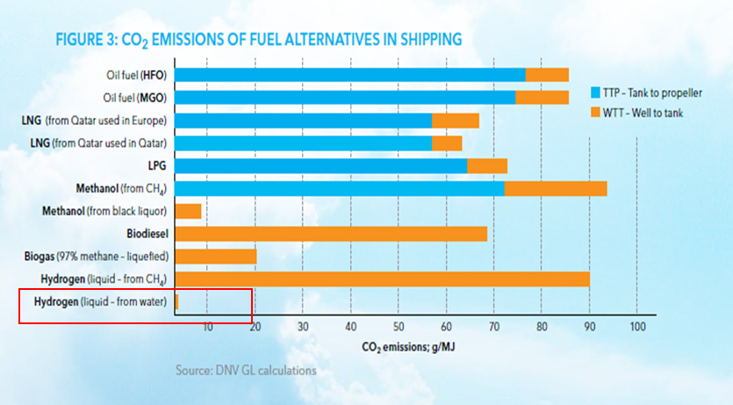Hydrogen fuel, if produced from renewables, is a promising zero-emission solution drastically reducing CO2 emissions in comparison to heavy fuel oil (see figure below) eliminating NOx, SOx and Particulate Matter emissions.

Figure 3 - CO2 emissions of fuel alternatives

Adapted to any type of transport, hydrogen presents itself as a promising substitute for petroleum which could accelerate the decarbonation of transport, provided that it becomes economically competitive.

Hydrogen has a high specific energy in joule or kWh/kg, but a low energy density compared to other fuels. At lower heating value it contains 120 MJ/kg or 33.3 kWh/ kg and has a density of 0.08 kg/m3 in gaseous form at a pressure of 1 bar and 70.8 kg/m3 in liquid form. By reducing the temperature of the hydrogen to – 253 degrees Celcius it converts to liquid form, which is a more suitable for distribution of large quantities. LH2 at 0.1 MPa (1 bar) contains about four times the energy per volume unit than does compressed hydrogen at 25MPa’s (250 bar) and almost three times as much than for 35 MPa’s (350 bar). Thanks to higher volumetric energy density liquid hydrogen offers an alternative for heavy-duty and long-haul mobility (ships, plane) but there is no technical solution available at acceptable costs.



Figure 4 - Fuel energetic density comparison

The objective of the project is to develop a technical solution reducing drastically the cost of hydrogen liquefaction.

The development of this liquefaction technology will accelerate the decarbonization of heavy-duty and long-distance transport: maritime and river but also road, rail, air.

Liquefied hydrogen provides a solution to the specific autonomy/power needs and storage constraints of these sectors.

Regarding road transport, the distribution of renewable liquid hydrogen for heavy goods vehicles will allow ENGIE to complete its alternative multi-fuel offer (electric charging stations, gaseous and liquid hydrogen) within its network of NGV stations - as presented in ENGIE Rhyzomes project (an applicant for the IPCEI) - and thus propose the zero-emission alternative best suited to the type of vehicle (light to heavy) and to use (occasional to intensive).

* + 1. Objectives of the project

There is a need to unlock the LH2 market by developing high performance solution for renewable LH2 production by optimizing the efficiency of liquefaction process and to propose to client innovative turnkey and onboard solutions addressing new uses (sea, road and air transports), solutions requiring liquid handing & integration expertise on the whole value chain.

The project aims to support France and Europe on the development of the renewable and/or carbon-free liquid hydrogen sector for heavy-duty and long-haul transportation. Specifically, the project aims to offer an alternative to petroleum products, which is both ambitious (Zero Emission) and resilient (based on local assets and resources and capable of ensuring a smooth transition).

In a first approach, the project will focus on heavy maritime and river mobility but the results may be used for air, rail and road transportation sectors.

The project enables technological barriers to be overcome through R&D projects; it allows for the demonstration of the feasibility of the on-ground segment (supply chain from renewable hydrogen production and liquefaction to the refueling station) and the on-board segment (operation of Zero Emission vessels) through initial industrialization, and finally the development of a complete infrastructure network allowing widespread use through massification and replication of the on-ground and on-board segments.

* + 1. Roadmap

In order to prepare for the massive deployment of liquid hydrogen solutions for the benefit of heavy-duty transport with Zero Emission across the entire value chain (on-ground and on-board segments), the project includes:

* **A Research & Development phase which will fully performed in France with partners of the consortium (R&D, point 21 in IPCEI Communication)**.:
* Development of energy efficient liquefier technology adapted to the deployment of a secure structure adaptable to changing needs and located as close as possible to consumers and / or resources (water + electricity from Renewable Energy (RE) or decarbonized coproduced hydrogen in case of circular economy),
* **A First Industrial Deployment phase (FID, point 22 in IPCEI Communication) with a first LH2 production unit to lay the foundations and demonstrate the feasibility**:
* Installation of a liquid hydrogen production unit of 10 T/day in a European port to supply a ship of 10MW.
* Launching of a zero-emission ship of 10 MW (150m feeder) using liquid hydrogen

**• A massification phase of industrial deployment (Environment, energy and transport projects, point 23 in IPCEI Communication) with the industrialization of the means of production for the developed equipment in France, with 30 LH2 production units and at least 3 in France allowing widespread use of the solutions developed:**

* Industrialization of the means of production for the developed equipment in France
* Installation a least of 30 liquid hydrogen production units of 10 T/day in Europe by 2040

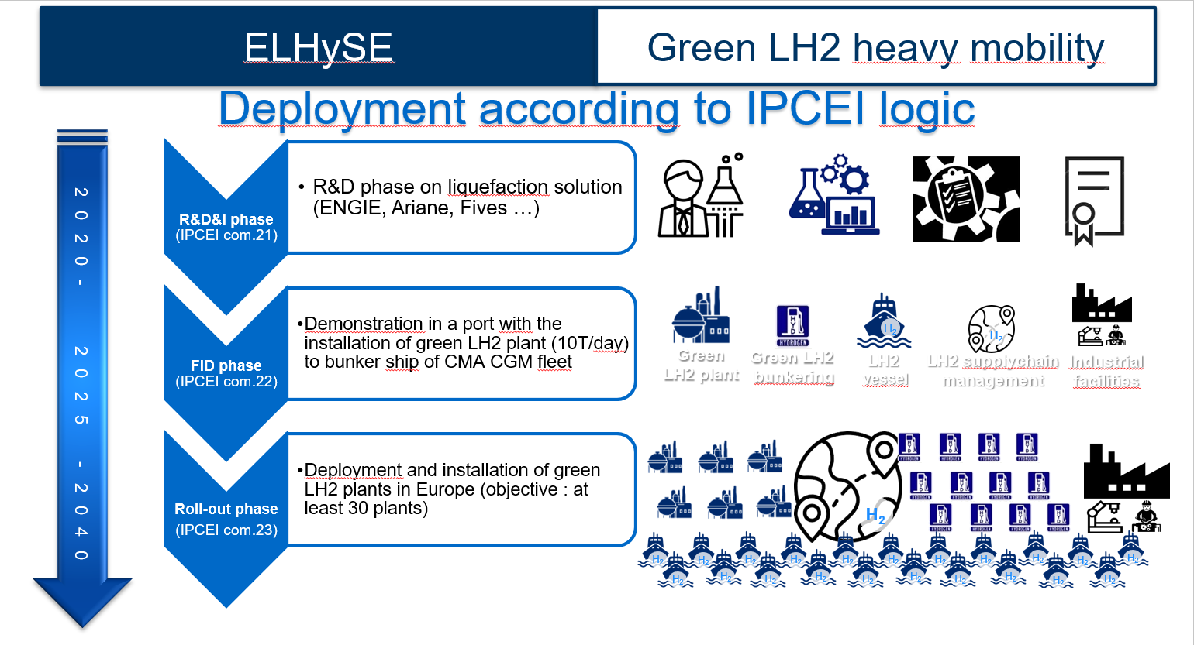

Figure 5 - ELHySE consortium roadmap

Technologies previously supported at industrial and national level will be deployed, thus bringing technological breakthroughs in the hydrogen sector and heavy-duty mobility. Additionally, the innovative nature of this project is also that it aims to deploy infrastructures that are resilient to the different energy transition scenarios:

* Wide compatibility: compatibility with the various Renewable Energies (RE) and low-carbon energies for the ground segment, possibility of making energy mixes on the on-board segment, etc.
* Adaptive to the pace of massification: liquefaction trains with variable capacity, easily deployable production and distribution units as close as possible to consumption areas, etc.
* Independent of imported resources
* Consistent with Zero Emission ambitions.
  + 1. Preliminary planning

The preliminary macroscopic planning of the project is as follows:

**2020 – 2024: R&D phase on liquefaction in France**

* 1st phase (2020): Development of the innovative liquefaction cycle and tests plan definition. 0.5 t/day test bench design
* 2nd phase (2021 & 2022): 0.5 t/day test bench installation and tests campaign on ArianeGroup R&D site of Vernon
* 3rd phase (2023 & 2024): 10 t/day demonstrator building and test on ArianeGroup R&D site of Vernon
* In parallel, prospection to find partners for the first industrial deployment

**2025 – 2029: FID phase, LH2 production unit in France or in Europe**

During this step we propose to transfer the LH2 production unit of 10 t/d to a port in order to supply a first type of ship of 10 MW running on LH2. Storage and loading system will be developed specifically.

For the first industrial deployment of a ship's bunkering and operating stations, the different European maritime coastlines will be investigated, among which the "Northern European Range" (HAROPA, Dunkirk, Rotterdam, Antwerp, Hamburg, etc.), the Mediterranean basin (Marseille, Toulon, Sète, Barcelona, Valencia, Malta, Trieste, Genoa, ...), the Scandinavian basin.

With the expertise and support of the partners which will be integrated into this project, this first deployment will establish a European standard across the value chain and set the foundation for a rapid and massive industrialization of this sector.

The "Agile" methodology integrated into the development processes should make it possible to initiate industrial deployment in parallel with the development program.

**2030+: Massification with 30 LH2 production units e**

During this step, the objective is to deploy and install 30 production plants in Europe (with at least 3 in France) to supply renewable liquid hydrogen supply chain for heavy-duty mobility

**This project therefore aims to achieve several strategic challenges:**

* Develop and industrialize technologies allowing rapid deployment of a job-creating liquid hydrogen industry,
* Establish an efficient and resilient supply chain deployable at French, European and global levels,
* Demonstrate a Zero Emission heavy-duty transport capacity on ships, compatible with the challenges of the energy transition.

This project aims to put in place the solid bases of a massification of the production of renewable liquid hydrogen for the benefit of heavy-duty mobility. For this reason and knowing the prospective nature of the industrialists' commitment to the energy transition desired by the public authorities in this early stage of industrial deployment, a significant public support is requested.

* 1. R&D Projects Before IPCEI for ENGIE

ENGIE is a global reference in low-carbon energy and services. In response to the urgency of climate change, ENGIE ambition is to become the world leader in the zero-carbon transition for the customers, in particular global companies and local authorities.

ENGIE develops its business (electricity, natural gas, new energies and services) providing highly efficient and innovative energy and services solutions to residential, commercial and industrial customers. ENGIE is highly involved in the development of sustainable and renewable energies from their production to their uses in cities and territories. In this context, since many years, ENGIE has been involved in the development of renewable hydrogen offers at national, European and International levels. Within its activities, ENGIE is positioned on the whole renewable hydrogen value chain from renewable production, renewable hydrogen production, short / long distance transportation, small / large scale storage, to final energy uses as industry or mobility for example.

Positioned in energy and associated services, as major multi-energy utility player in both natural gas sector and green power, ENGIE is involved in grid and market coupling within H2/NG projects and is convinced that hydrogen will play an essential role to decarbonize the energy system and optimize the integration of renewables.

ENGIE Lab CRIGEN, part of the ENGIE Labs network, is ENGIE Group’s corporate centre for R&D and high-level expertise devoted to new energy resources (hydrogen, biogas and gas liquefaction), new energy uses in towns and cities, the buildings and industries of tomorrow and emerging technologies (computer sciences and Al, drones and robots, nanotechnologies and sensors).

ENGIE Lab CRIGEN conducts operational R&D projects and develops pilots on behalf of ENGIE Group corporate research, Business Units (BUs) and external customers, with the goal of mastering tomorrow's technologies, bringing them to maturity, and preparing the energy transition. Its ability to innovate is a key advantage for the ENGIE Group. Through collaborative projects and demonstrators, technologies developments and assessments for new businesses, standardization & regulation. ENGIE Lab CRIGEN covers 3 main areas:

• Improvement of Industrial activities’ performance

• Integration of new technologies and business intelligence and methodologies

• Development of low carbon energy solutions

Regarding H2 development specifically, the aim for ENGIE is to pave the way for a competitive zero-carbon hydrogen economy thanks to three main goals:

* lower the costs of the whole renewable hydrogen value chain to enable 100% green gas by 2050
* identify, assess and integrate innovative solutions to answer the new needs of ENGIE’s clients towards a zero-carbon target (renewable hydrogen for industrials, for mobility and for territories)
* valorise existing infrastructures by providing energy transition solution to assets owner (power to gas and network conversion with hydrogen conversion)

Among the numerous references of ENGIE on H2 R&D project, the more outstanding for this IPCEI application are the following ones:

* Development of the GRHYD project founded by ADEME, to produce H2 from renewable electricity, inject this H2 into the gas distribution grid and consume H2-NG gas locally (Residential use, heating, cooking, hot water, CHP, and mobility).
* Participation in the PRHYDE consortium founded by FCHJU. The PRHYDE project aims at building the foundations of heavy-duty refueling protocols for large tank systems (> 10kg) used in heavy duty hydrogen applications such as trucks or trains. The objectives of PRHYDE are therefore to determine relevant requirements for Heavy Duty Vehicles (HDV) fueling, determine limitations and gaps of current fueling hardware capability, develop concept(s) for HDV fueling protocol(s), based on thermodynamic simulation (1D and 3D) and experimental campaign, formulate recommendations for HDV fueling protocol(s) for use in relevant standardization group with the aim of achieving standardization.
* Participation in the METROHYVE consortium founded by FCHJU. The Metrohyve 2 project aims at leveraging metrological challenges in the sector of hydrogen mobility such as flow metering in refueling station, sampling and analyzing hydrogen fuel quality and assessing the impact of impurities on fuel cells. ENGIE will develop and test a new mobile sampling and analysis methodology for punctual hydrogen quality analysis, allowing to analyze hydrogen quality directly at the station avoiding to send samples to laboratory, thus increasing representativity of the analysis and reducing hydrogen quality analysis cost for the operator.
* Development of modelling tools to simulation hydrogen tank refuelling and hydrogen refuelling station for compressed gaseous hydrogen.
* Patent of new hydrogen liquefaction process to decrease liquefaction cost.
* Development of a logistic tool based on applied mathematics and cryogenic expertise to optimize LH2 supply chain. The OptiH2 is selected to be presented during Gastech 2020 conference.
* First development on LH2 thermodynamic models based on ENGIE worldwide recognized expertise in LNG thermodynamic behaviour modelling.
  1. Technology and Challenges – R&D&I Activities within IPCEI in all technical fields it’s involved

Hydrogen liquefaction process is usually divided in three parts which are:

* The compression system, where the refrigerant gas for the cooling cycle is pressurized;
* The pre-cooling section, where the hydrogen is cooled down to a temperature between 80K (-193°C) and 100K (-173°C) in multi-stage heat exchangers by the expansion of a pre-cooling refrigerant gas ;
* The cooling cycle, where the hydrogen is cooled down to 21 K (-252°C) in multi-stage heat exchangers by the expansion of the refrigerant gas and where the hydrogen is liquefied at the end by throttling in a Joule-Thomson valve.



Figure 6 - Liquefaction cycle description

The state of the art and the technical challenges are described followed by the targeted advances that will be developed within this project together with the innovation potential, i.e. the anticipated developments and innovations this project will initiate/support.

* + 1. State of the art and technical locks for LH2 liquefaction

Pre-cooling

The current process uses nitrogen in an open-loop to pre-cool the hydrogen feed to 80K (-193°C). As illustrated in Figure 6, liquid nitrogen is supplied in a scrubber to separate vaporized gas from condensed nitrogen. The liquid nitrogen flows in the second heat exchanger (HX2) and cools the hydrogen to 80K (-193°C). Catalytic conversion is proceeded in this heat exchanger consuming LN2 cold power. The gaseous nitrogen, from the nitrogen separator, is mixed to the one coming from HX2. The mixture provides cold power in the first heat exchanger to cool hydrogen and refrigerant from ambient temperature to approximatively 100K (-173°C). Eventually, nitrogen at ambient temperature is rejected in the atmosphere. This unit is consuming approximately 6 – 8 kgLN2/kgLH2, and is responsible for about 30% of the total process SEC with consumption between 3.5 – 4.5 kWh/kgLH2 (A.Hubert, H.Broqua, & H.Filali, 2019)*.* This specific energy consumption calculated for the precooling depends in this case of a liquid nitrogen open cycle on the penalty factored in for LN2 consumption (0.4 kWh/ l LN2).



HX2

HX1

GN2

Figure 7: Process flow diagram of nitrogen open-loop pre-cooling cycle in Linde

Such open-cycles are widely implemented in existing plants and conceptual designs as summarized in Table 1. According to the current available data, every installed plant, except Kourou’s (Air Liquide) uses open-cycle pre-cooling. An explanation is proposed by A. Hubert who highlighted the proximity to air cryogenic installations supplying thus easily liquid nitrogen to hydrogen liquefaction plants. Moreover, this technology doesn’t require any heavy and costly mechanical equipment such as compressors.

In Development of a small-scale hydrogen liquefaction system (2015), N. M. Garceau et al. designed a liquefier to produce 1 L/h of LH2 at 3 bar with a single stage Gifford-McMahon cryocooler. The liquefier includes two ortho-para hydrogen converters, a liquid nitrogen precooler and a heat pipe. It illustrates well the interest to use liquid nitrogen in open-cycle for small-scale liquid hydrogen production in order to limit capital outlays and maintenance costs.

|  |  |  |  |  |
| --- | --- | --- | --- | --- |
| Provider or Author | Type | Production (TPD) | Refrigeration system | SEC1 (kWh/kgLH2) |
| Praxair | Plant | 35 | N2 pre-cooling to 80K (-193°C) and H2 Claude cycle. | 12.5-15 |
| Linde Ingolstadt | Plant | 4.4 | N2 pre-cooling to 80K (-193°C) and H2 Claude cycle | 13-15 |
| Linde Leuna | Plant | 5 | N2 pre-cooling to 80K (-193°C) and H2 Claude cycle | 12 |
| Air Liquide (Hylial) | Application | 2.5 | N2 pre-cooling to 80K (-193°C) and He Brayton cycle. | N/A |
| KIST2 & FSEC3 | Theoretical cycle | 0.02 | N2 pre-cooling to 80K (-193°C)  and He Brayton cycle | N/A |
| WE-NET | Theoretical cycle | 300 | N2 pre-cooling to 80K (-193°C) and H2 Claude cycle | N/A |

*1 : Specific Energy Consumption ; 2: Korea Institute of Science and Technology ; 3 : Florida Solar Energy Center*

Table 1: Existing plant and theoretical cycle using LN2 pre-cooling overview (adapted from L. Madelaine, 2018)

However, considering the context of hydrogen liquefaction development, open-cycle for the pre-cooling shows several limits. Indeed, the hydrogen liquefaction plants are now more unlikely to be installed next to Air Separation Units implying the organization of a supply chain for liquid nitrogen. Additionally, the need to increase the capacity to at least 100 TPD to meet viable liquefaction costs implies a more intense nitrogen supply chain and thus an increase of OPEX cost. Moreover, part of the green hydrogen production and thus liquefaction are likely to be located in solar-rich area such as mountains and deserts where nitrogen supply is uncertain to be easily provided. Finally, used as storage medium for power to gas/gas to power in isolated location such as islands, the same limited supply chain implies to design the liquefaction process as autonomous as possible. With an increase of the liquefaction capacity, it might be profitable to switch to an internal less critical process such as a closed-loop.

Cooling cycles

Most of liquid hydrogen plants, date back to the 1980’s and are operated by Air Products (US), Praxair (US), Linde(GE), Kawasaki (JAP) and Air Liquide(FR).

|  |  |  |  |  |  |  |  |
| --- | --- | --- | --- | --- | --- | --- | --- |
| Suppliers | Range (TPD) | Since | Cycle | Open LN2 | O-P Conversion | SEC (kWh/kgLH2) | Economics (M€) |
| Linde | 5-7 | 1992/2007 | Claude with H2 | X | Batch | 13.6 | *20 for Leuna* |
| Praxair | 6-35 | 1962 | Claude with H2 | X | Continuous | 12.5-15 |  |
| Air Products | 0.3-32 |  |  |  |  |  |  |
| Air Liquide | 5-12 | 1980 | Claude with H2 |  |  | 12-13 | 135 announced for a new 30 TPD plant (maybe with a new technology) |
| Hylial  (Air Liquide) | 1-2.5 | 2007 | Turbo Brayton |  |  | 9.9 | Modular offer |
| Kawasaki |  | 2014 | Claude with H2 | X |  |  |  |

Table 2 - Existing LH2 plants main properties

Researches are done on conceptual plants to improve the efficiency with SEC usually about 7 instead of 12-15 kWh/kgLH2, and the exergy efficiency rise to about 50%. The conversion to p-H2 also is usually higher than 95%. Unlike in the actual plants, many researches are focusing on the use of mixed refrigerant (MR) or Ne/He as precooling system. Conversion often takes place in a continuous way, or continuously after a first adiabatic stage at 130-80K.

* Matsuda and Nagamei (WE-NET), (1996)

WE-NET has worked on 3 large scale projects of 300 TPD. They are delivering liquid hydrogen at 1.06 bar from a feed stream of equal pressure. Three cycles were studied: the Hydrogen Claude cycle, the helium Brayton cycle and the neon Brayton cycle. The following conditions in Table 3 were defined for the study.

|  |  |  |  |  |  |  |  |
| --- | --- | --- | --- | --- | --- | --- | --- |
| Capacity  (TPD) | Feed  (bar) | Tank Capacity  (kL) | Outlet  (bar) | Boil off  (%mass/d) | Turbine efficiency  (%) | Compressor efficiency  (%) | Process efficiency (Carnot) (%) |
| 300 | 1.06 | 50 000 | 1.06 | 0.1 | 85 | 80 | 40 |

Table 3 - Liquefaction process conditions

* Hydrogen Claude cycle

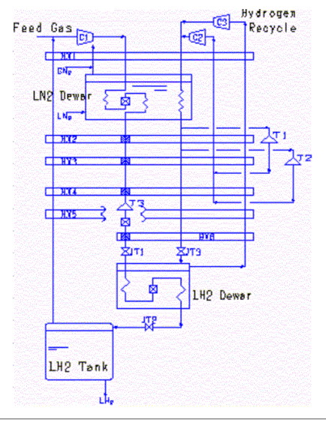

Figure 8 - Hydrogen Claude cycle

|  |  |  |  |  |
| --- | --- | --- | --- | --- |
| Feed | Refrigeration cycle | Precooling | Ortho/Para conversion | SEC  (KWh/kgLH2) |
| Compressed at 50 bar | Claude | LN2 at 80K | Continuous and non-continuous (batch) | 8.5 |

Table 4 - Hydrogen Claude cycle parameters

As displayed in Figure 7, there is an important N2 liquefaction system to liquefy N2 for the precooling process. At low temperature the main process stream of H2 is expanded in a supercritical low-temperature expander to an intermediate pressure level, limited to above the critical pressure of hydrogen to avoid a two-phase condition at the outlet. Further sub-cooling takes place before the stream of H2 is partially liquefied by a Joule–Thompson expansion. The flash gas is then internally heat-exchanged and recycled to the feed gas compressor.

* Helium Brayton Cycle

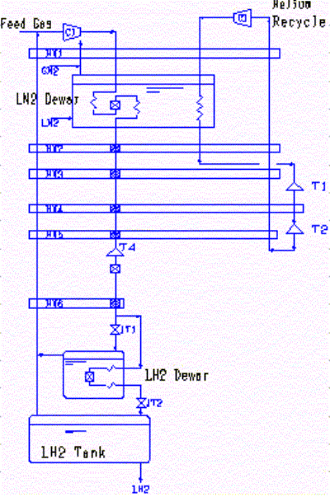

Figure 9 - Helium Brayton cycle

The Helium Brayton cycle in Figure 8 could be adopted for relatively small hydrogen liquefaction plants. Helium gas is used in the recycling line. The pressure conditions of the feed gas, the installation of the super critical turbine and O/P conversion of the feed hydrogen are almost the same as the Hydrogen Claude cycle. **Source spécifiée non valide.**

* Neon Brayton cycle

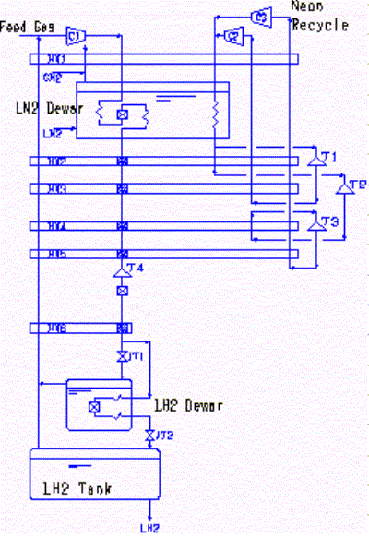

Figure 10 - Neon Brayton cycle with cold pump

In order to reduce the number of compression stages, a gas of large molecular weight is used as recycling media. Indeed, it is difficult to compress a gas of small molecular weight to high pressure. Thus, hydrogen and helium used in the recycling line are not suitable considering the size of the plant. One possibility is to use neon as shown in Figure 9. Though it will require lots of energy to reduce the saturated pressure by a room temperature compressor, a process with a **cold pump** has been developed to do the same work with smaller power input. Each process efficiency (Carnot) is better than the target of 40%.

* + - Kuendig et al.

Kuendig et al conducted a study regarding the integration of a pre-cooling LNG system to a new one like the Leuna N2 pre-cooled Claude system (Linde). The study concluded that using LNG for pre-cooling in the hydrogen liquefaction process would be extremely useful to decrease the power input and the overall liquefier cost because the cold source would be “free”. Indeed, LNG is regasified before being injected in the grid, so a synergy between the 2 systems is possible. Compared to a conventional liquefaction process, such as the one at Leuna, using liquid nitrogen for precooling but with compression at ambient temperature, the reduction would be from 10 to 4 kWh/kgLH2. The process, as shown in Figure 10, is using **13.1 kgLNG/kgLH2**



Figure 11 - PFD Claude cycle with LNG precooling according

* + - Kuzmenko et al.

The helium Brayton cycle developed by Kuzmenko et al. achieves the refrigeration capacity solely with expansion turbines. The parameters of this cycle are listed in Table5below.

|  |  |  |  |
| --- | --- | --- | --- |
| Capacity  (TPD) | Refrigeration cycle | Precooling | SEC  (kWh/kgLH2) |
| 5 TPD | Brayton | LN2 | 12.3 to 13.4 |

Table 5 - Hydrogen Brayton cycle parameters

Higher energy efficiency could be achieved by applying recycle compressors with lower power consumption, as shown in Figure 11, and by optimizing the refrigeration loop with expansion turbines and finally via a Joule-Thomson valve. In practice, systems based on the helium Brayton cycle are applied for smaller capacities of up to 3TPD where economics are more sensitive to capital investment than to operating costs.

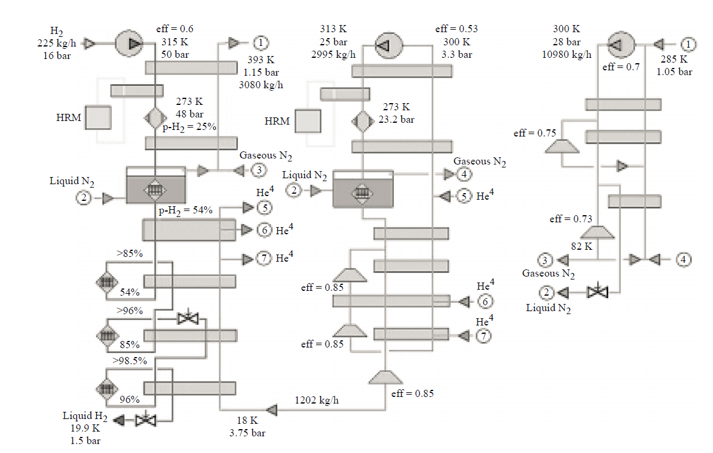

Figure 12 - Helium Brayton Cycle by

* + - Valenti-Macchi (2008)

Valenti-Macchi proposed an innovative, high-efficiency, large-scale hydrogen liquefier using four cascaded helium Joule-Brayton cycles. Table 6 is showing the parameters of the process.

|  |  |  |  |  |  |
| --- | --- | --- | --- | --- | --- |
| Capacity  (kg/s) | Refrigeration cycle | Precooling | Ortho/Para conversion | Electrical liquefaction work  (MJ/kgh2) | Second law yield  (%) |
| 10 | Joule-Brayton | LN2 at 80K | Continuous at 20.5K and 60 bar | 18.14 | 47.73 |

Table 6 - Hydrogen Joule Brayton cycle by parameters

The innovation lies in the fact that the 10 kg/s (around 800 TPD) is refrigerated in heat exchangers catalytically promoting the ortho-para conversion down to the low temperature of 20.5K and at the high pressure of 60 bar. As described in Figure 12, H2 is expanded to the storage conditions (1.5 bar and 20K) through a liquid phase turbomachine. Refrigeration is done via 4 helium recuperative Joule-Brayton cycles. Compression is accomplished in 15 intercooled 8 stage devices derived from gas turbine technology. **Source spécifiée non valide.** The expander (indicated by T0) replaces the throttling valve commonly used in order to avoid vapor generation and minimizing entropy production.

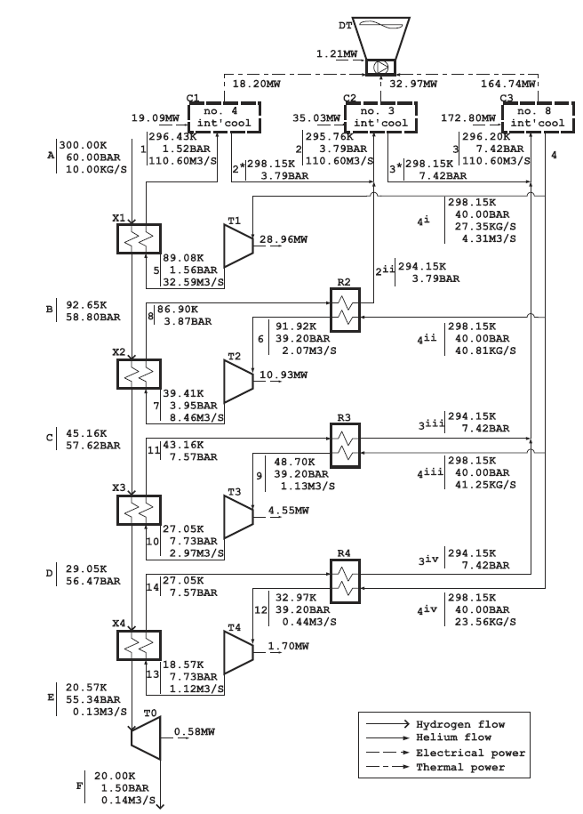

Figure 13 - Helium Joule-Brayton cycles by

Helium is not suitable for cooling H2 from 25 to -193°C and from -193 to -253°C due to its inferior heat transfer properties compared to hydrogen. Moreover, the cycle’s configuration itself to cool H2 from 25°C to near -193°C makes it impossible to have low exergy efficiency as reported. Also, simulation tests run indicated that the system is not guaranteed to have a high efficiency.

* + - Quack (2002)

The 150 TPD range process is composed of 4 parts, as detailed in Figure 13 below*:*

* ***H2 compression***

Feed is compressed from 1 to 80 bars in five stages. Article mentions that only four stages are possible, but it reduces the energetic efficiency though it decreases the capital expenditure.

* ***Propane pre-cooling: 20°C to -53°C***

An objection to this process design is the low-pressure propane refrigeration stage. For pure propane providing cooling at an evaporation temperature of 217K, the corresponding evaporation gauge pressure becomes negative in the simulation.

* ***Nelium (20% mol Neon) inverted two stage Brayton cycle: -53°C to -248°C***

* ***Liquefaction through gas rotating expander***

The remaining gas portion represents about 9 % of total stream. The excess gas is recompressed to 8 bars, sub-cooled and liquefied through J-T valve.

Continuous o-p conversion takes place during the cooling process. The parameters of the Quack process are listed in Table 7 Below:

|  |  |  |  |  |
| --- | --- | --- | --- | --- |
| Capacity  (TPD) | Feed  (bar) | Outlet  (bar) | Boil off  (%mass/d) | Efficiency (Carnot)  (%) |
| 150 | 1 | 1 | 0.1 | 40 |

Table 7 - Quack parameters table (2002)



Figure 14 - Quack approach process flow sheet

* + - IdealHY (2013)

IdealHY is a European research project coordinated by SHELL GLOBAL SOLUTIONS with many partners (both academic and industrial) such as Linde Kryotechnik AG, SINTEF ENERGI AS, the universities of Loughborough, Technishe Dresden, and others like North Energy Associates ltd, Weka AG, Planet Planungsgruppe Energie Und Technik Gbr.

The project started in 2011 to last until the end of 2013 with a European budget of 2,117 M€. A sub project in Netherlands is currently taking place at La Hague (last update in June 2018).

The 50 TPD range process is composed of three parts, as shown in Figure 14:

* ***MR pre-cooling: 20°C to -143°C***

MR (consisting of nitrogen, methane, ethane, propane and butane) whose temperature goes down to about 130 K

* ***Nelium cooling: -143°C to -253°C***

* ***Liquefaction through expansion***

Para flash-gas is mixed with expanded H2 not to lose gaseous p-H2 in the process.

Ortho-para conversion mostly takes place during the second refrigeration step. There is no information about catalyst.

Eventually, IdealHY proposes synergy with LNG regasification. It requires LNG cold power and a H2 feed at 40-80 bars. It evacuates the first stage compression (2 M€ for 40 TPD plant) and the MR pre-cooling (5 M€ for a 50 TPD plant).

By combining LNG facility, the energy efficiency of liquid hydrogen production can be improved from to 2-3.2 kWh/kgLH2. For the production of 1kg of liquid hydrogen, 20.4kg of LNG is needed.

The final value for liquefaction cost the study offers is **1.72€/kgLH2.**

Table 8 is summarizing IdealHY parameters.

|  |  |  |  |  |  |  |
| --- | --- | --- | --- | --- | --- | --- |
| Capacity  *(TPD)* | Feed  (bar) | Outlet  (bar) | Boil off  (%mass/d) | Para H2 content  (%) | Compressor efficiency  (%) | Liquefaction COST  (€/kgLH2) |
| 50 | 21 | 1.06 | 0.1 | 95 | 80 | 1.72 |

Table 8 – IdealHY parameters table (2013)



Figure 15 - IdealHY approach process flow sheet

* + - Krasae-in (2014):

Krasae and his team have designed a large-scale **conceptual plant** for hydrogen liquefaction. Its initial range is about 100 TPD though later in the article, the author also proposes to build it as a **modular system with the exact same cycle** within the equipment size availability: 50/50; 33/33/33; 25/25/25/25. **Source spécifiée non valide.**

The **100 TPD** is supposed to cover the consumption of **100,000 – 200,000 hydrogen vehicles**.

The article was released during summer 2010 and offered the design for a particularly efficient liquid hydrogen plant. The SEC is about 5.35 kWh/kgLH2 with a thermodynamic cycle value of 2.86 kWh/kgLH2.The team conducted the process simulations on the **PRO/II software** package using Soave-Redlich-Kwong (SRK) model equation.

The 100 TPD range process is composed of two parts, as shown in Figure 15 on next page.

* ***MR pre-cooling: 20°C to -193°C***

1.2% hydrogen, 13.6% nitrogen, 13.6% methane, 15.2% R14, 16.2% ethane, 11.4% propene, 6.4% propane, 1.7% I-butane, 1.7% butane, and 18.9% pentane.

* ***H2 Joule Brayton cascade cooling: -193°C to -253°C***

It is better to use H2 in cascade refrigeration than helium in Quack’s design. Heat discharge after compressor is higher because of better heat properties for H2. Moreover, compressor power is lower because of smaller flow rate in the case where H2 is used as a refrigerant. After the last expansion, a small ejector is recommended to recover p-GH2 from the tank.

Ortho-para conversion is stepwise-made during both MR and cascade refrigeration. No information about catalyst is given.

***Assumptions about the process are the following:***

* No pressure drops because sizes aren’t stated yet
* Compressor and expander’s isentropic efficiency is assumed to be 80%
* Mechanical conversion of work in expander is 98%
* Feed and stream compositions stated in the article (table)
* Give which paper to check for SRK model accuracy
* Pressure ranges for compressors are determined through trial and error optimum and not values given by constructor. Thus, flow sheet adaptation might be needed at some point.

The parameters of Krasae-in’s process are listed in Table9 below:

|  |  |  |  |  |  |  |
| --- | --- | --- | --- | --- | --- | --- |
| Capacity  (TPD) | Feed  (bar) | Outlet  (bar) | Para H2 content  (%) | Boil off  (%mass/d) | Compressor efficiency  (%) | SEC  (kWh/kgLH2) |
| 100 | 25 | 1.3 | 95 | 0.1 | 80 | 5.35 |

Table 9 - Krasae-in parameters table



Figure 16 - Krasae-in approach process flow sheet

Compressors and expanders systems

**Compressor.** The initial step in the liquefaction process is the compression of the gas stream and of the coolant stream (depending on the thermodynamic cycle). For the compression stage all operational LH2 plants use multi-stage volumetric compressors (in the form of piston compressors or screw compressors) with intercoolers (water cooled) within each stage. High pressure oil is used to lubricate the pistons and the screws with the additional benefit of contributing to the removal of the heat of compression in order to reach for an isothermal compression. Additional cooling is provided by means of recirculating circuits within the piston chamber walls. Such compressors are driven by an electrical motor (in the range of several MWe) working at optimum speed (moderate speed of the order to 600 - 1000 rpm).

An example of the state of the art is the Linde/Leuna plant H2 compressor (feed stream of the H2/H2 refrigerated cycle) working between 1 and 30 bar for a maximum production rate of 5 tpd. The compressor is a PV422 reciprocating piston compressor from BORSIG bmh with a maximum capacity of 22000 m3/h.

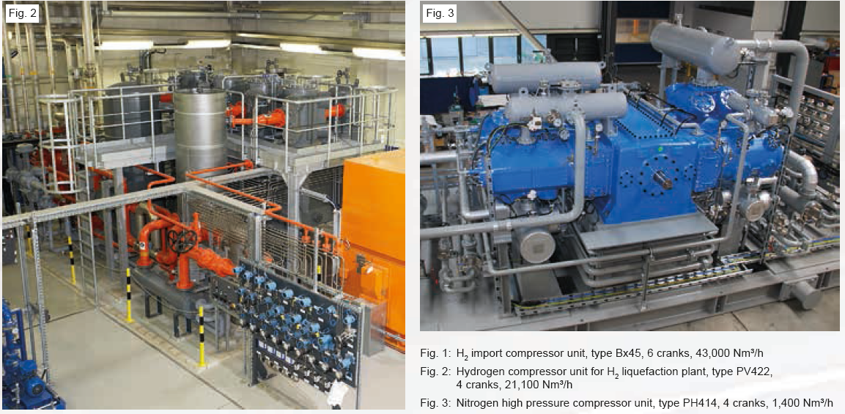

Figure 17 - H2 compressors examples

The compressed gas is then processed by an additional oil-removal system designed to prevent the oil mist carried by the gas to enter the cold box (the risk is the flow blockage due to the solidification of the oil at low temperatures as long as the contamination of the catalyst bed) by means of a cascade of several filters and cyclone separators. Additional equipment is used to control the start-up of the compressor, oil temperature control, HMS monitoring and integration within the liquefier C&C system.

**Expanders.** High efficient liquefaction cycles use centrifugal expanders in order to reduce the working fluid enthalpy (thus its temperature) by removing work for the high-pressure stream by means of a turbine (generally centripetal). The work is transferred to a brake in the form of a compressor impeller and dissipated by means of compressing a temperature-controlled brake gas (normally the process fluid) thus wasted in the form of heat.

Such rotating machines work at high speed (in the range of 100 000 rpm or higher) due to mass flow rates and optimum functional performance requirements using dynamic or static gas bearings (for radial and axial balance) for longer life duration. An example of such expanders is provided in the following image:

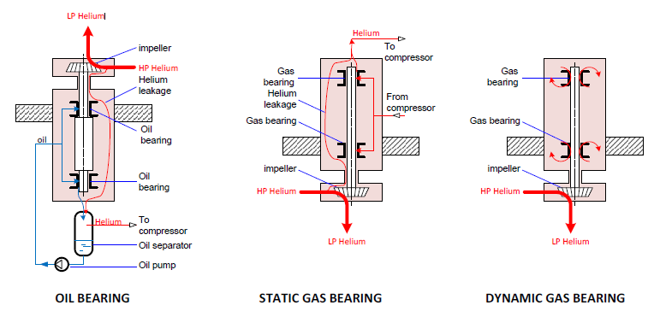

Figure 18 - Expanders schematic diagram

Gas bearing turbines use a gas film in the bearings to eliminate the risk of an oil contamination of the process gas. Further advantages of gas bearing turbines include higher turbine isentropic efficiencies, reduced space requirements and higher turbine reliability. Therefore, modern hydrogen liquefiers are often equipped with either static or dynamic gas bearing turbine technology.

In already built hydrogen liquefiers, the mechanical energy produced in the cryogenic turbines is currently dissipated. The exergy efficiency of the hydrogen liquefaction process can be increased by recovering the turbine energy by powering a compressor. Such architecture is called a turbine-compressor unit, a process gas stream is compressed in a turbo compressor which is coupled to the turbine shaft and is driven by the turbine disc. A process design with turbine-compressors units is more complex: it requires an optimum matching of the process and the machine design on both the turbine and the compressor side. The constraints imposed by the mechanical coupling of the turbine and the compressor can have a negative impact on the performance of the refrigeration process.

* + 1. Objectives and technical challenges in the project

In this step we propose to install a test bench in order to develop a new process for liquefaction of renewable hydrogen. The aim of doing a hydrogen liquefaction test bench is to better understand liquid hydrogen. Some tests to perform on the bench are already identified. These tests will lead to development of equipment and process optimization (pre-cooling and cooling cycle). Alternative solutions to the current and usual processes will be developed. The following table is presenting the different tests and the anticipated impact on the test bench.

The technical challenges of the design of the liquefaction plant will be managed by ArianeGroup and ENGIE in partnership with FivesCryo for the topics regarding specifically heat exchanger and catalyst.

Pre-cooling and cooling cycles

**Thermodynamic properties of hydrogen show that pressure should be maximized, and parahydrogen used as cooling refrigerant in the process**. Pressure increase leads to optimized thermal properties but as well to higher cost of equipment while parahydrogen comes out to improve hydrogen capacity to absorb heat. Those optimizations have to be balanced to ensure profitable implementations.

**Nitrogen open-loop for precooling is replaceable with alternative refrigerant systems such as nitrogen closed-loop (NCL) or hydrocarbons mixed refrigerant (MRC).** Current technology consumes 3,0 kWh/kg representing 30% of the specific energy consumption (SEC). NCL or MRC use **divides the SEC up by two** despite they increase slightly capital investment. Free cold generated in ENGIE LNG-terminals is also considered as an innovative way to valorise LNG cold-coming from regasification process while leading to cheap pre-cooling.

**Mixing hydrogen with neon or helium is a promising way to reduce SEC by 30%.** Despite hydrogen shows excellent thermal properties, intermediate cooling refrigerant such as neon or alternative main refrigerant such as helium are considered to be excellent vector to **complement hydrogen poor flow properties.** Due to extremely low temperature, only those gases work and there is a lack for adapted modelling system.

**Technological improvement of catalytic heat exchangers, compressors and turbine expanders lead to increase of their performance**. New model of plate-fin heat exchangers offering better efficiency are in development to reduce exergy destruction occurring in the refrigeration cycle. However kinetic model for catalysis and heat exchangers computing have to be tackled to design them at best.

**Changing compressor material or shifting to a more efficient type such as turbo-compressor are current options to improve compression efficiency**. This is highly required since refrigeration loop’s compressor consumes 60% of the energy supplied to liquefy hydrogen being thus main power consumer, Technical development of advanced high-speed turbo-compressors adapted to hydrogen with titanium may lead to achieve higher pressure ratio, **reducing the number of compression stage** and thus the CAPEX.

**Promising ongoing development showed an overview of some possible alternative technologies to overcome current limitation** although long term qualification procedures will be required which will likely allow implementation on a long-term basis only. **Assisting or replacing mechanical compressor with ejectors** allow both a reduction of SEC and CAPEX by reducing compressor volumetric inlet. On the same principle**, metal hydride hydrogen compressor** uses physio-chemistry energy to supply high-pressure. Finally, **Stirling reverse machine is the most disruptive alternative** since it eliminates totally the need of compressor. Both last solutions’ drawback is their small-scale capacity. Further studies are needed to explore the technical and economic aspects of those technologies to confirm their true potential which can be achieved thank to the test bench development.

The following table is presenting the different tests and the anticipated impacts on the test bench design.

|  |  |  |
| --- | --- | --- |
| Part of the liquefaction cycle to be tested | Explanation | Impact on test bench (0.5 t/d) design |
| Precooling fluid | As shown previously the bench will be first design using LN2 as precoolant. However, the idea of using LNG should be studied. | The use of LNG for precooling require an additional heat exchanger to respect the BOG conditions and to keep a positive temperature at the compressor inlet. |
| Refrigerant fluid employed | The close refrigeration loop is currently design using H2. Some conceptual plants are using other fluid, such as mix refrigerant or a neon/helium mixture for instance. | Allowing the possibility of changing the fluid used in the loop. |
| Precooling loop | More than the fluid used for precooling, the precooling cycle itself can be modify. For instance, using a close loop (LN2 or LNG), or an open loop cycle using mix refrigerant (neon/helium or hydrocarbons MR). | The precooling cycle must be modifiable without having to modify too much the overall process. |
| Compression ratio | The clod in the refrigeration loop is bring by the expansion/compression effect. The pressure ratio variation impact could be studied. | It will require flexible compressors and expanders to be able to process at different pressure. Select equipment that can support different pressure in a given interval. |
| Catalyst material used | The effect of different catalyst for the ortho-para conversion could be studied. | Allowing the possibility of changing the catalyst in heat exchangers. | |
| Production capacity | The bench will be design for a LH2 production flowrate fixed (0.5 t/d). It could be interesting to have flexibility and be able to produce a little more. | The bench must be designed to be flexible on flowrate, such as oversize some equipment. | |

Table 10 - Tests to perform on cooling and precooling systems

The results of these tests will be used to optimize the design of the 10 t/d liquefaction process

Compressors and expanders systems

**Compressors**

The main technical challenges for the use of turbo compressors in hydrogen liquefiers is the optimized design combining the low compression pressure ratio that is feasible per stage (meaning multiple stages), the bearing and sealing systems for high rotational speeds as long as the high power drivers. The scale up of the LH2 production thus requires the development and testing of hermetically-sealed high speed centrifugal compressors with magnetic bearings in order to achieve high efficiencies with theoretically zero refrigerant losses during the operation and no wear. The synergies of the LH2 cycle coupled with a LNG heat sink (vaporization unit) can lead to a highly integrated compressor system with reduced number of stages in which the compressor electrical motor driver is also cooled by the LNG.

**Expanders**

As for the case of the compressor the global cycle efficiency is directly affected by the expander efficiency. A major challenge in the up-scaling of hydrogen liquefaction processes are the capacity limitations of the current state-of-the-art expansion turbine designs as the maximum capacity of existing gas bearing turbines in built hydrogen liquefiers is thus smaller compared to the turbine size that is required for future large-scale hydrogen liquefaction processes. The currently available capacities of cryogenic turbines are limited by turbine powers levels of approximately ~ 50 kW with dynamic gas bearing. Larger sized oil bearing turbines or magnetic bearing turbines with a turbine power PTU ranging from a few kilowatts to several megawatts are employed in other as state of- the-art industrial cryogenic processes, for example in air separation units at higher temperatures (minimum temperature corresponds to the liquefaction of N2). However, the current design of these very large oil-bearing turbines and magnetic bearing turbines is currently not proven for the use with the cryogenic fluids such as the hydrogen. Further technology development and industrial qualification procedures are needed before these turbine design modifications can be applied to hydrogen liquefaction processes with low risks.

Additional performance increase in a broad spectrum ranging from mechanical integration, thermal design of the cold box, simplification of the assembly and integration process and global cycle performance are offered by the using of a turbine-generator unit consists of an electric generator which is coupled to the turbine to convert mechanical power into electrical power to be fed either back to the liquefier or to the grid. The transfer of the turbine energy recovery technologies to the cryogenic refrigeration cycle in hydrogen liquefiers is feasible within the medium-term but is technically challenging particularly with respect to the overall system architecture for high reliabilities and ease of maintenance. A large expertise has been acquired in the development of flight-rated high-speed electrical turbomachinery within the Ariane 6 launcher program.

The following table is presenting the different tests and the anticipated impact on the solution design.

|  |  |  |  |
| --- | --- | --- | --- |
| Part of the liquefaction cycle to be tested | Explanation | Impact on test bench (0.5 t/d) design | |
| Compression system | Usual hydrogen compressor is currently considered. However, shifting to more efficient type could allow to achieve higher pressure ratio and to reduce the number of stages.  Options are for instance using turbo-compressor, assisting or replacing mechanical compressor with ejectors or using metal hybrid hydrogen compressors. | | The first compression system used must be easily replaceable. |
| Eliminated the need of compressors | As compressor represent the major part of equipment cost investment finding an alternative would be economically interesting.  The use of Stirling reverse machine could be studied. Further studies on this point are needed to explore technical and economic aspects of the solution. | | It would totally modify the precooling part and the refrigeration system of process. |
| Catalytic heat exchanger technology | New models of plate-fin heat exchangers offering better efficiency are currently in development. It could be a promising solution to reduce exergy consumption of the process. | | The first heat exchangers used must be easily replaceable. |
| Pressurized feed | Pressure increase leads to optimized thermal properties but as well higher cost of equipment. Those optimizations have to be tested and balances for profitable implementations. | It must be designed to be flexible on pressure. equipment selection that can support different pressure in a given interval. | |

Table **Erreur ! Pas de séquence spécifié.** - Tests to perform on compressors and expanders systems

The results of these tests will be used to optimize the design of the 10 t/d liquefaction process

At the end of the R&D phase, the 10 t/d demonstrator will be ready to be transferred to the industrial partner site

* 1. First Industrial Deployment (FID)
     1. Purpose of the FID phase

Engie will build and install a first integrated project including the production of renewable LH2 and bunkering infrastructures in a port to supply a first ship of CMA CGM.

The objective is to validate the performance of the liquefaction process on an industrial scale by increasing the production flow rate and to integrate the process with renewable hydrogen production (or already coproduced hydrogen in circular economy) and bunkering infrastructure.

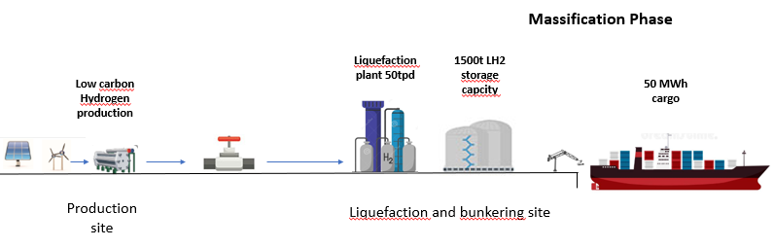

**Liquefaction plant 10 tpd**

**10 MW**

Figure 19 - FID supply chain scheme

Thus, the FID in Elhyse will consist in deploying the first-in-kind equipment and facilities which cover the steps subsequent to the pilot line including the testing phase.

* + 1. Technical challenges in the FID phase

At this step, it is essential to test at scale the process validated on the pilot and validate the integration of the LH2 production to global LH2 supply chain.

To successfully prepare the development of the market and the massification, different technical challenges have to be solved:

* **LH2 production plan**

The aim will be the performance validation at full scale and during different operational conditions (ramp-up …). From 2025 to 2030 the total capacity of production will progressively ramp up to reach the 10 t/d. Indeed we can assume that during FID phase, operational issues will occur and some developments and adjustments of the chain will be required.

* **The storage system**

The full containment tank system will certainly be the first of a kind for liquid hydrogen and material used, insulation, boil off management while also facing adjustments/corrective actions for daily operations. All feedback regarding this tank design will be used for the next generation of storage during massification phase.

A cold system will be designed first to re-liquefied boil-off hydrogen from tank storage which will vary according to pressure and temperature conditions of the tank, and whose capacity might also be adjusted to precooling system (loading arm, ship manifold, pipeline,..) needs according to loading operation feedback.

* **LH2 bunkering station**

No existing LH2 bunkering are existing out of the shelf. Some elements will be derived from existing loading system for LNG, but insulation requirement will far more stringent and will imply specific development.

Equipment and system are likely to face problems in operational mode, with for some of them further efforts required in R&D to solve them.

* **Loading system**

For a good articulation of the loading system, specific swivel joint with high insulation system that will be developed for LH2 will be tested in real condition. Possible mechanical limitation adjustment and thermal remedies will require additional R&D to improve it. The development will be based on LNG loading arms already existing in the industry

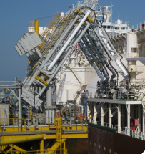

Figure 20 - Example of LNG loading arms

Pipeline connection between storage and loading system will be vacuum thermally isolated and specially developed.

All the possible heat transfers with transfer pump, pipes, equipment, loading arm and ship manifold will be minimized in order to limit the boil off gas as low as 10% of the cargo.

High speed immerged LH2 pump will be designed in order to handle the loading of the 150t in 1-2 hour time.

Loading management, will be tested on the storage tank before installation on board and then in real condition with the tank on board and the loading system. These real conditions will lead to optimize the system sprinklers in case of no vapor generation or sizing of the return vapor arm in case of vapor generation. The number of loading arm and number of storage tanks on board might be reconsidered to increase loading rate. Thermal losses could appear on the loading arm and will trigger new or improvement of the insulation system. All these elements will lead to modification on the system and the loading protocol.

The automatized loading system coupled with emergency release systems will certainly require adjustments of electronic system in real conditions. Insulation might be modified according to operating conditions in order to minimize thermal losses.

* **Industrial facilities for LH2 supply chain equipment production**

Also, as one of the main goals of the project is to create a new industrial sector based on new technologies developed during the R&D&I phase and not to duplicate an existing one. Thus, main of the processes to be used for Manufacture, Assemble, Integrate, and Test the corresponding products are not yet qualified (for sure), selected nor identified (for some of them).

In consequence, a programme of Development & Innovation and Qualification of the industrial processes must be defined in parallel of the R&D&I IPCEI’s phase and implemented during the FID IPCEI’s phase, in particular to integrate the product’s QCDRS objectives and Factory 4.0 model.

The FID phase will end when QCDRS objectives associated to Full Operational Capacity (FOC) are reached. These objectives are associated to the FOC necessary to produce the full batch of system and equipment corresponding to the LH2 production plants, LH2 bunkering stations and LH2 vessels to be implemented during the FID phase.

* **LH2 Vessel**

Most of upcoming or delivered initiatives are for much smaller vessels than chartered by containerized shipping liner. However, hydrogen technology became more and more efficient and feasible for this specific use and more projects start with different perspective. The LH2 vessels reference mentioned below will help to design and operate the LH2 vessel

* **Vessels with compressed hydrogen**

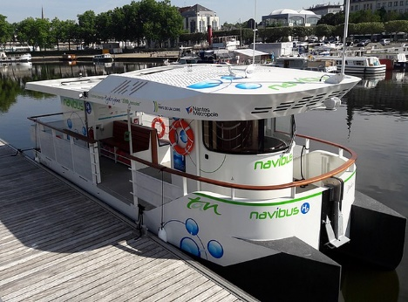

**The Jules Vernes 2,** since mid-2018 is the first French river shuttle, this 13m overall Length Navibus is equipped with two H2 tank array, 430 bar compressed gas, two fuel cells, which convert hydrogen into electricity stored on board, with 2 x 5 kW AC supplied by hydrogen station equipped with 12X450 bar compressed gas

Figure 14: Jules Vernes 2

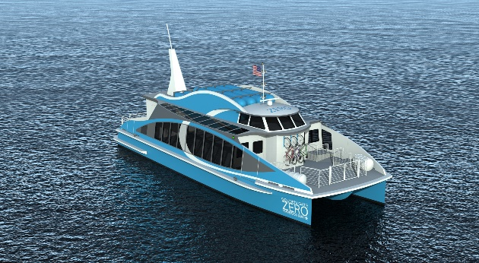

**Water-Go-Round** launched in mid-2019 will be the first fuel cell vessel in the US and the first commercial fuel cell ferry. Built by GGZEM and its partners, this vessel will be equipped with H2 tank array 264 kg, 250 bar compressed gas, up to 2 full days operation, 2x 300 kW (400 hp) shaft motors (1 in each demi-hull), 100 kWh batteries in hulls provide boost power to achieve 22 knots. The vessels should be 21m overall Length.

Figure 15: Water-Go-Round

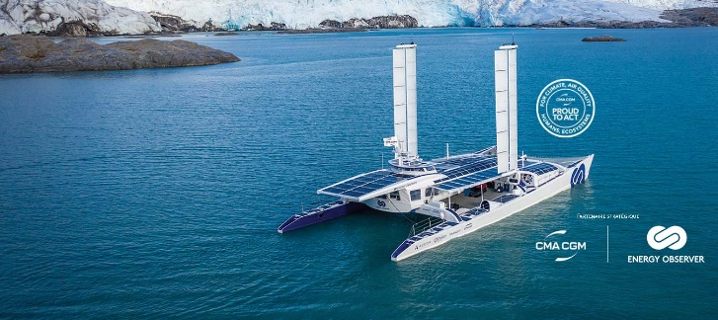**Energy Observer** since mid-2018 is the first French river shuttle, this 13m overall Length Navibus is equipped with two H2 tank array, 430 bar compressed gas, two fuel cells, which convert hydrogen into electricity stored on board, with 2 x 5 kW AC supplied by hydrogen station equipped with 12X450 bar compressed gas.

Figure 16: Energy Observer

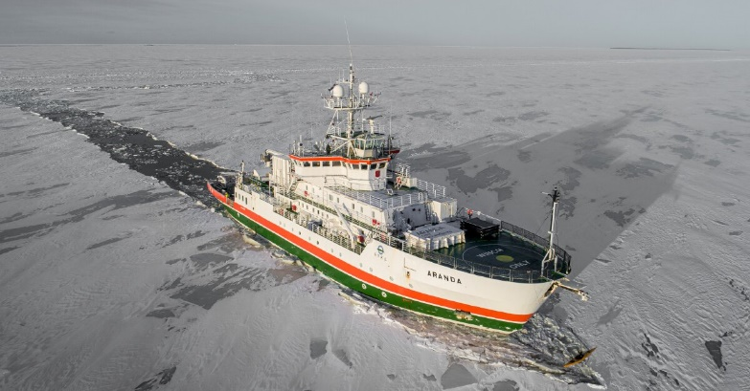

**MARANDA** project is an emission-free hydrogen fueled PEMFC based hybrid powertrain system developed for marine applications on board the research vessel **Arandas**, 66m overall Length. It will be equipped by Q4 2020 with 165 kW (2 x 82.5 kW AC) fuel cell powertrain (hybridized with a battery) to provide power to the vessel's electrical equipment as well as the dynamic positioning during measurements, free from vibration, noise and air pollution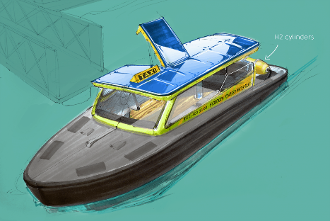

Figure 17: Arandas research vessel

* **Vessels with liquified hydrogen**

**SWIM** project is a water taxi running on hydrogen, initiated by Enviu as part of Enviu’s zero-emission shipping program, it should be running about 2021.

Figure 18: SWIM taxi

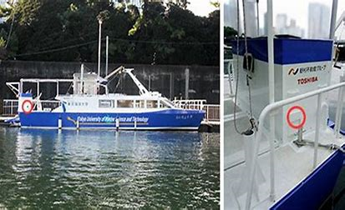

**Raicho N (1**) was developed as part of a joint research project with NREG Toshiba Building, part of the Nomura Real Estate Group, and Tokyo University of Marine Science and Technology and singe 2016Toshiba’s is testing a 3.5kW pure hydrogen fuel cell system on this 20m long vessel.

Figure 19: Raicho N

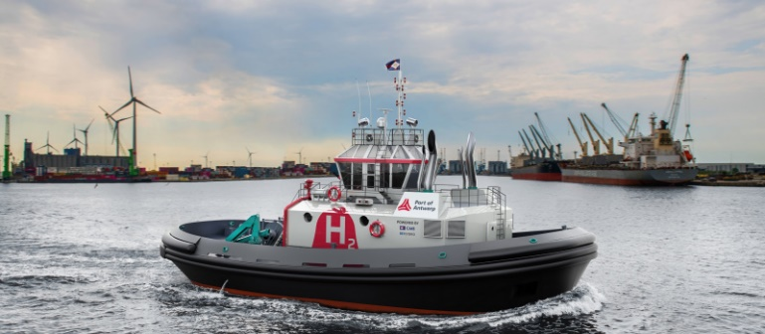

**BeHydro /hydrotug** is a 20m long with hybrid system running on liquid hydrogen in combination with diesel and liquid hydrogen system will provide 2.8 MW / each. This Hydrotug will be the first vessel that boasts 400 kW of power on this dual technology

Figure 20: BeHydro

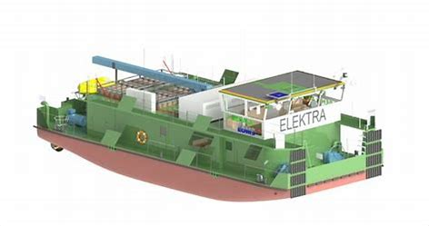**e4ship/Elektra** is a hybrid canal push boat powered by a combination of fuel cells, batteries and an electric motor. This 20m long push boat will be equipped with two 200kW propellers. Fuel cell technology is being leveraged for hydrogen-fed baseload energy supply for the powertrain and onboard grid. Accumulators are harnessed for peak loads. ELEKTRA is not only investigating hydrogen’s feasibility as an energy store given its specific properties, researchers can study the dynamic interactions between the energy sources and identify and also extend the maximum range of a canal tugboat.

Figure 21: ELEKTRA push boat

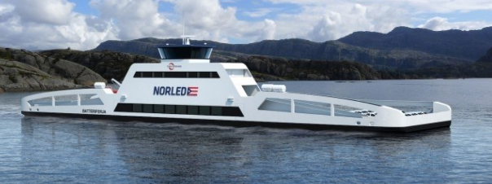

**FLAGShips** 3×200 kW PEM fuel cell modules supplied by Ballard Power Systems Europe, the H2 storage (250bar gaseous with 600 kg total capacity) should be able to supply fuel of 260 km operation / day and fuel a 500kW battery

Figure 22: flagships project

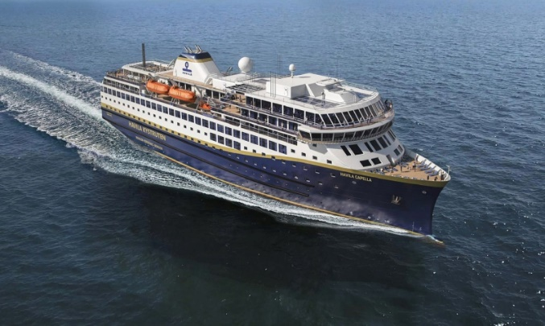

**Kystruten** is one-year contract for design and technical specifications for a zero emissions system fully classifiable and in conformity with IMO maritime safety requirements. The system solution that PowerCell and Havyard jointly will design, will be based on several marinized 200 kW fuel cell system modules connected in parallel with a total power of 3.2 MW.

Figure 23: Keystuten vessel

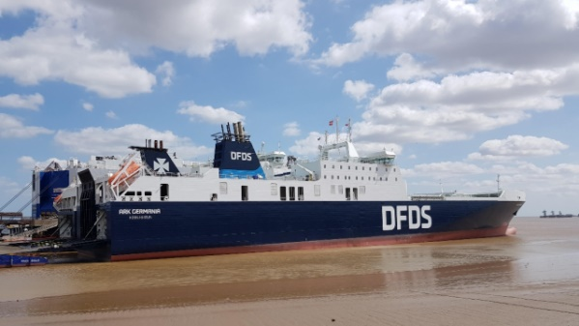**Ark Germania** this ro-ro freight vessel will provide a platform for testing fuel cell technology. This 195m vessel will be adapted to enable the installation and testing of fuel cell plant during its regular operations in order to compare performance of each technologies on this specific constraint and assisting a total output of 18,000kW propulsion system allow tests of fuel cells up to 1MW.

Figure 24: Ark Germania

**Ark Dania is the next step** were designed to accommodate military transport needs as well as catering to DFDS’ varied ro-ro cargo manifests, with capacity for 3,000 lane-meters of wheeled freight, corresponding to some 185 heavy goods vehicles, plus 342TEU containers. Each is powered by two low-speed MAN main engines of the 8S40ME-B9 type, giving a total output of 18,000kW, driving twin controllable pitch propellers. While contractual speed was stipulated at 20.5 knots, the service speed criterion for usual North Sea transits was 18.6-18.7 knots.

**Raicho N (2) after Raicho N (1)** This time Toshiba is about to test its technology with a fuel cell ship, which is installed with a larger 30kW pure hydrogen fuel cell system, but we don’t have further information on the this POC.

Today, there are only limited ship projects using H2 or aiming at using LH2 as fuel. The list of main projects is presented in the following table. We can observe that the maximal ship power is lower than the usual demand for a container ship.

|  |  |  |  |  |  |  |  |  |
| --- | --- | --- | --- | --- | --- | --- | --- | --- |
| **Project name** | **Use case** | **Delivery** | **Compagny** | **Ship Lenght** | **Hydrogen powering system** | **Distance km** | **Yard** | **Energy** |
| FlAgships | push boat | 2021 | Compagnie Fluviale de Transport / Norled / NCE Maritime CleanTech/ FCH2 JU / maritime OEM ABB/ LMG Marin / Ballard Europe / PersEE / VTT / Westcon Power & Automation | 100 passengers ~30m | 200 kW (1MW total) | 260 | N/A | fuel cell + liquid (Norway) / Gas (France) |
| Water-Go-Round | e-ferry | 2019 | All American Marine / SW/TCH + Clean Marine Energy | 100 passengers ~21m | 2x300 kW | 2days of use | N/A | fuel cell + Gas 250 bar |
| SKYE Aranda | research vessel | Q4 2020 | Kemira / centre de recherche technique de Finlande VTT | 66m | 2 x 82.5 kW | N/A | N/A | fuel cell + Gas 350 bar |
| navette Jules Verne 2 | ferry | 2019 | Air Liquide/villes de Nantes | 10m | 2x5 kW | 13 | 12 x 420bars (1000km) | fuel cell + liquid |
| SWIM | taxi | 2021 | Watertaxi Rotterdam/Enviu | ~10m | N/A | N/A | N/A | fuel cell + liquid |
| Energy Observer | demonstration | 2017/ 2020 | Toyota/air Liquide | ~30m | 114 kW | 550 | N/A | fuel cell +gas(production onbord) |
| Raicho N (1) | ferry | 2016 | Toshiba / Université des Sciences et Technologies marines de Tokyo | 14m | 3.5 kW | N/A | H2One™ Station Unit” | fuel cell + liquid |
| Raicho N (2) | ferry | 2020 | Toshiba / Université des Sciences et Technologies marines de Tokyo | N/A | 30 kW | N/A | N/A | fuel cell + liquid |
| KYSTRUTEN | Cruise/ferry | 2022 | PowerCell Sweden/ Havyard Group / Havila Kystruten/Volvo Group/Linde | ~123m | 200 kW / 3,2 MW total | N/A | N/A | fuel cell + liquid |
| e4ship Elektra | push boat | 2020 | Behala / Ballard /Anleg GmbH Schiffswerft Hermann Barthel shipyard / Imperial Logistics / Schiffselektronik Rostock / EST-Floattech / Technical University in Berlin. | 20 | 100 kW | N/A | N/A | fuel cell + solar cell + liquid |
| BeHydro Hydrotug | push boat | 2021 | Compagnie Maritime Belge / | 20 | 2.8 MW / each | N/A | N/A | fuel cell + liquid + diesel |
| Ark Germania Ark Dania | Carier | 2020 | DFDS/The Blue Denmark /Danish and German defense ministries | 195.2m ~ 342TEU | >1 MW (need 18,000kW) | N/A | N/A | fuel cell + other |

Table 11 - ship projects using H2 or aiming at using LH2 as fuel

* + 1. Transition from the FID phase to the mass production / commercialisation phase

**The objective of this Massification is to develop by 2040, 30 LH2 production plants and at least 3 in France**

During this phase, we propose to deploy 30 LH2 plants of 10 T/day and associated bunkering infrastructures for ships, trains or plane. The objective is to develop a first network of plants able to produce a quantity of LH2 needed for heavy-duty mobility by LH2 in Europe.The return of experience of the first industrial deployment should allow improvement and the scaling up of capacity. Industrialisation of equipment production should allow a drop in costs.

In comparison to FID, the final LH2 global supply chain will have, at least, the following improvement:

* For the bunkering terminal, the required LH2 storage up to 3500m3 will imply larger full containment tank system.
* To minimize the time for refuelling several loading systems will be put in place in parallel, while submersible LH2 pump should be ready to handle a higher loading rate.

ENGIE has the know-how, expertise, knowledge of the markets and technologies, and the necessary means to develop quickly the massification phase. By joining its forces with ArianeGroup and CMA-CGM in France and at European level with the players able to complete the on-ground segment (equipment manufacturers, port authorities, etc.) and the on-board segment (design offices, equipment manufacturers, integrators, shipyards, certification authorities, etc.) the partners will provided a real added value and a significant impact for the competitive and large-scale development of the renewable liquid hydrogen sector. Partners will accelerate the supply of economically viable and resilient solutions as well as safe and efficient equipment in France and in Europe.

It should be remind in this part that most of the equipment will be produced and assembled in France to be deployed in Europe (liquefier equipment will be built and integrated at Vernon site of ArianeGroup, exchangers should be built in France by FivesCryo …)

* + 1. Revenues in the FID phase

During the first 3 years of the FID phase, production will be limited due to frequent starts and stops to adjust the process, replace pieces of equipment, improve thermal insulation. Even if it will ram up the poor reliability of the production will prevent from any sales agreement. During the first two years most part of the production might be sold on spot for mobility or industrial usages, and starting during the second year production will be provided for the first rotation with an LH2 ship. But not enough in a regular basis to ensure all rotation of the ship. All these elements lead to consider a discount on the price of LH2 delivered which will slightly increase during these 3 years. With the end of FID phase, with a process under control and regular production, sales agreement will be in place at an expected price.

Revenues during the FID phase will be thus seriously reduced.

* 1. Environmental, energy or transport projects before the IPCEI

**Mobilization of the sector around hydrogen projects:**

In concrete terms, two categories of projects are identified for the development of green hydrogen solutions:

* **Many small, diffuse projects,** supported for some by the ADEME's calls for projects (Mobility and Industry)
* **Large-scale projects**, which aim to reduce costs and accelerate territorial mesh developments in a sustainable manner, with an industrial vision and which will enable COP21 commitments to be fulfilled.

**Today, small and diffuse projects alone will not allow the development of the French sector and the existing devices are not sufficient to bring forth large-scale projects that will nevertheless be** the foundation of the French **hydrogen sector.**

For green hydrogen to become rapidly competitive, it is necessary to develop large-scale projects, massive production, to benefit from a learning curve and scale effect (virtuous circle, synergies, automation of production processes). **The solution is to develop industrial-scale projects now.**

The industrial sites with a hydrogen consumption substitutable by decarbonized production could represent anchor points for industrial-scale deployment at first and then to respond to new, more diffuse uses that will take place over time.

ENGIE's strategy is part of this dynamic and consists of establishing a first industrial benchmark to operate the gradual deployment of a larger-scale set of industrial and territorial hubs for all types of uses: industry, heavy mobility (trains, ships, etc.), intensive mobility (bus, fleet vehicles, etc.), network support service and seasonal storage.

**ENGIE, for its part, is mobilizing for the deployment of renewable hydrogen**

ENGIE has created a business unit dedicated to renewable hydrogen in January 2018

ENGIE is committed to the French state:

* **Contrat Stratégique de Filière (CSF)**

The "New Energy Systems" CSF, chaired by ENGIE, covers, among other things, the subject of the production and storage of decarbonized hydrogen.

10-year target: 30% of hydrogen produced is low carbon by 2030

2-year target: assembly of the first consortiums in connection with hydrogen manufacturers and producers

The sector is committed to working closely with the downstream sector (chemistry, agri-food, construction, etc.) to achieve a massification of demand and thus allow a reduction in the prices of low carbon hydrogen.

The State is committed to "de-establishing and putting in place the best conditions to ensure, in the long run, the economic and environmental competitiveness of these hydrogen solutions by defining a legal and support framework adapted to an industrial deployment of hydrogen by the consortiums created, especially in terms of traceability”.

The CSF was signed by ENGIE on May 29, 2019

* **Green Growth Commitments (ECV)**

The ECV approach is strongly inspired by an initiative launched in the Netherlands, which has been replicated in France in sectors other than hydrogen. **The aim is to identify the obstacles to be overcome and the levers necessary for the implementation of hydrogen projects, and to indicate in concrete terms on what actions the industrialists, on the one hand, and the State, on the other, are committed.**

**The ECVs do not contain a commitment of financial support from the State, but rather aid on the regulatory level, on coordination between the various actors of the State, and on other cross-cutting actions.**

The ECV hydrogen process was launched after the publication of the Hulot Plan (June 1, 2018). The Department has entrusted the management of the project to the CEA and AFHYPAC.

ENGIE has signed the two Green Growth Commitments (ECVs) "decarbonized hydrogen production for industrial uses" and "mobility" which have been finalized.

Regarding the first ECV, ENGIE signed a commitment to "plan renewable or low carbon hydrogen production and storage solutions on industrial hubs that are already producing and/or consuming hydrogen such as refineries, ammonia producers or steel".

ENGIE has contributed to the drafting of the ECV dedicated to maritime and river and will be a signatory.

* **ENGIE has submitted several projects under the AAP "mobility" and "industry"**

As of 2016, ENGIE had submitted 15 projects, 11 of which were labelled "Hydrogen Territories".

As part of the AAP "Mobility Ecosystems", ENGIE has submitted 6 projects (representing a total investment of 130 million euros) of which 4 have been selected by ADEME as part of the first call for projects (Zero emission Valley, HyPort, Hynovar, EFFI H2 Vannes) and 7 other projects as part of the most recent call for projects under investigation

As part of the AAP Industry, published in February 2019, ENGIE has submitted 6 out of 11 projects in total. **5 projects were selected (3 of which were carried by ENGIE).**

ENGIE also responded, in partnership with EO Dev, to AAP ECOGEN (clean solutions for decarbonized energy production, notably for the 2024 Olympic Games) published in July 2019.

ENGIE is involved in many projects submitted to French AMI H2 on 15/04/2020 among them the **following ones related to ports - maritime/inland shipping:** AMI Ô H2 Rhône with CNR, VNR and GPMM; AMI Vallée Hydrogène Grand Ouest with LHYFE, EO DEV, La Manche, SYDEV and Morbihan Energies; AMI CENAQ on onshore power supply with GPMM, KEM ONE, LINDE, HELION ; AMI MHYNA with Nouryon, Port of Bordeaux, Bordeaux Métropole on top of AMI ElHyse with ArianeGroup and CMA CGM.

* **ENGIE - HYNOVAR Project**

If we add to the data of tourist traffic (cruises, ferries, island services, yachting), those of domestic traffic intra-harbour of metropolitan maritime buses, the Rade de Toulon, with its 5 million passengers transported annually, is the 2nd Port of France just behind Calais, the number 1 with its 11 million (excluding military traffic). On the other side of the coin, the Rade de Toulon is now facing air quality problems related to mobility, particularly maritime ones. But the Var is mobilizing to find an innovative, ecological and driving solution for the local economy.

HYNOVAR was born from the initiative of HySeas Energy, the CCI VAR, ENGIE, the Paul Ricard Circuit and the Bateliers de la Cote d’Azur to develop a large-capacity hydrogen sea shuttle, refueled by a land-based station. First 2 stations constitute the founding industrial bricks of the project.

The port area of Toulon - port of Brégaillon, with a green hydrogen production unit (404 kg/day), will find first captive users as soon as it is commissioned with a tourist maritime shuttle (about 200 passengers, the 7th of the Bateliers de la Côte d'Azur, net reduction of 615 T of CO2/year) and 7 H2 buses deployed by the metropolis Toulon Provence. The port of Brégaillon is a strategic location. It is a hub for boats, buses, trucks and heavy logistics (rail, loco-tractors).

The Castellet circuit, with a production unit (20 kg/day), will supply a fleet of 20 Light Utility Vehicles to be offered as car-sharing around the Signes activity area.

The prospect of powering ships docked with a fuel cell is also under consideration. The vessels involved are essentially long-haul ferries. They need electricity (2.7 MW) during their stops to operate heating/air conditioning, kitchens, maintain lighting on board... Today, they use their fuel-powered engine. Connecting these vessels to a hydrogen fuel cell would shut down the engines at the dock and thus reduce a large part of the nuisance (pollution, noise) generated by these ports of call. This type of connection already exists for military vessels. However, the network is not able to provide the necessary power during peak consumption. The use of a fuel cell is a real innovation to solve a public health problem and promote hydrogen in other ports. The planned production and distribution station at the port of Brégaillon will make hydrogen available for this type of use.

Yachting and boating are also serious development avenues already under consideration.

* **ENGIE, Partner of Energy Observer**

Around the world, a new path is emerging. A path linked to a profound questioning of our responsibility to future generations. A path that also brings out solutions for more harmonious progress. It is within this transformation that the ENGIE x ENERGY OBSERVER partnership is taking place.

Faced with the ecological challenges of the 21st century, ENGIE plays a decisive role in the field of energy. At the heart of a radical transformation of its activities, the Group reveals projects that embody the tremendous potential of the energy revolution.

A pioneer of the energy revolution, ENGIE aims to become the leader of the new world of decarbonized, decentralized and digitalized energy, and considers renewable hydrogen as one of the essential and missing links to build a more sustainable energy system and world to this day.

ENGIE is already active in hydrogen, to meet industrial needs, to develop sustainable mobility or to compensate for the intermittency of renewable energies in the form of storage. By becoming a partner of Energy Observer, ENGIE is supporting a unique demonstrator that proves the viability of a virtuous, decarbonized, decentralized and digitalized energy production system: Energy Observer is the first ship in the world capable of producing its hydrogen on board, thanks to the coupling of renewable energies (wind, solar, current) and seawater.

ENERGY OBSERVER is the first hydrogen vessel to be energy-free without greenhouse gas emissions or fine particulate matter. This propulsion vessel of the future operates thanks to a mix of renewable energies and a system of decarbonized hydrogen production from seawater. This technological and scientific challenge aims to test in extreme conditions state-of-the-art technologies foreshadowing the energy networks of tomorrow, applicable in terrestrial environments.

More than a boat with innovative technology, Energy Observer carries out a multi-year world tour, led by Victorian Erussard, founder and captain, and Jérôme Delafosse, expedition leader, to meet concrete solutions that prove that a dynamic of positive growth, reconciling economic growth and common good, is possible. ENGIE's teams are taking part in this adventure by presenting solutions that the Group is developing, which aim on the one hand to produce and distribute an increasingly clean energy, and on the other hand to help its customers - individuals, companies, territories... - to improve their energy use.

After a tour of France in 2017 designed to make the ship's technologies more reliable, a tour of the Mediterranean Sea in 2018, then a tour of Northern Europe to the Arctic in 2019, ENERGY OBSERVER is embarking this year on a world tour punctuated by major ocean crossings.

ENGIE supports Energy Observer, a symbol of our global ambition to contribute to Harmonious Progress. Pioneering in energy and services, ENGIE innovates and brings out concrete projects in the world that reconcile the interest of our customers and the collective interest for a more sustainable planet.

* 1. Importance of the project for the environmental, energy or transport strategy of the European Union

ArianeGroup, CMA CGM and ENGIE are joining forces to carry out an innovative and sustainable project that is fully in line with the long-term binding EU-wide net-zero emissions’ target by 2050 of the COP21 and the European Climate Law of the Green Deal[1]. It will also contribute to the Clean Energy Package 2030 ambitions in terms of renewable integration, decarbonisation and secured energy supply.

The project will contribute to the new EU Industrial Strategy[2] by fostering a new and competitive clean hydrogen lead market toward climate neutrality and clean transition of the mobility sector. This flagship project will be a milestone for the EU leadership and front runner position at global level in the green hydrogen economy, providing large scaling-up opportunities and technology learning rates in the heavy-duty mobility sector.

The project is also in line with the Renewable Energy Directive II as it has the potential to increase the share of renewable energy in the production of fuels, and therefore to help achieve the 14% renewable energy target within final energy consumption in the transport sector by 2030.

* + 1. Project’s contribution to the decarbonisation of the energy sector

The project aims at developing, industrializing and rolling-out a full liquid hydrogen supply chain for heavy mobility: maritime and river ships. It will use gaseous hydrogen as an input, produced from renewable energy. As such, the project will be key to unlock the full potential of local and intermittent renewable power production.

The hydrogen used on-board will mainly substitute heavy fuel oil which is the major fuel for merchant vessels as of today. Renewable or low-carbon hydrogen is currently not competitive compared to fossil fuels. The project will contribute to reducing the gap of competitiveness between fossil fuels and renewable or low-carbon hydrogen from the massification phase, ensuring a secure and affordable energy supply. Indeed, the massification of liquid hydrogen production as contemplated in the project will be key to reduce the cost of renewable and low-carbon hydrogen production by achieving economies of scale and improving the technology and processes to deploy and operates the infrastructures. The same will derive from the scale-up of end-use equipment manufacturing for the whole supply chain, from liquefaction to on-board bunkering and management systems.

France and the European Union are net importers of fuels. The project with therefore contribute to reinforcing the French and European Union’s strategic independence on the global energy market.

Hydrogen is a versatile energy vector: today widely consumed as an industrial raw material, it can also be used for mobility, electricity production or as fuel in gas networks. Renewable hydrogen can therefore make a significant contribution to greening the economy. There is an increasing desire on the part of the population, of customers, for green, which renewable hydrogen thus makes it possible to satisfy. Renewable hydrogen is necessarily part of the equation to drive the major change that is requested in the energy mix and meet the political and regulatory commitments.

The French government has taken the first steps in favour of renewable and low carbon hydrogen:

The “Plan national de déploiement de l’hydrogène décarboné”

The “Comité Stratégique de Filière”

The “Croissance Verte” commitments on hydrogen

The “Energie Climat” law

The ongoing works for the guarantees of origin.

Indeed, the cost of producing hydrogen is crucial to guarantee the competitiveness of the French industry. Only the combination of public support and scaling-up of production will reduce the production costs of renewable hydrogen by a factor two in 2030. Today there is a scientific consensus on reducing the costs of renewable H2: a significant drop in production costs is expected in all scenarios IRENA, IEA, BNEF, IHS, Mc Kinsey. According to these scenarios, renewable hydrogen would be competitive between 2030 and 2040. The Hydrogen Council estimates that the parity in terms of competitiveness between grey hydrogen and green hydrogen would be reached in 2030.

Succeeding in this transition, by initiating it quickly, on the right scale and with the right support, is therefore essential to meet French and European commitments in terms of reducing the carbon footprint and stay in the race on an international scale.

* + 1. Project’s contribution to the European industry’s innovation and global leadership in the green economy

The project will be a technological showcase that will shed light on products and start-ups and increase the liquid hydrogen expertise and knowledge all along the strategic value chain through:

* Pulling suppliers all across the value chain to innovate and increase their know-how
* A test platform to test equipment *in situ*
* Trainings on liquid hydrogen safety and management
* The integration of innovative technologies
  + 1. Project’s contribution to the rolling out of cleaner, cheaper and healthier forms of private and public transport

Hydrogen mobility only emits water, avoiding any air pollution and GHG effects. Hydrogen-propelled vessels can cover long distances and they can be refuelled quickly. Liquid hydrogen is particularly suitable for heavy-duty transport as it offers much more favourable energy density by volume. The project assumes that maritime and river ships will be converted from heavy fuel to hydrogen.

* + 1. Project’s contribution to creating new jobs in the green economy

This project will create jobs for the manufacturing of equipment in new industrial facilities. Digitalisation and automatization will be key features of these new factories. This will contribute to reinforce the competences based in Europe related to the green economy. When the workers will move to other companies, they will bring their experience with them and contribute to the diffusion of expertise in the green economy. This expertise will be highly demanded on the job market in the future because the people contributing to the project will have been the promoters of a first-of-a-kind that other companies in the industry will be willing to replicate.

* + 1. Other contributions to sustainable development

Hydrogen electric ships emit only water in the form of gas. According to Mobilité hydrogène France[3]:

* H2 ships decrease from 90% CO2 emissions compared to conventional ship
* H2 vehicles do not emit particles like NOx, SOx and Particulate matters
* H2 vehicles reduce noise.

Thus, the maritime and river ships targeted by the project will enable a considerable improvement of life quality by reducing air pollution, GHG effects and noise.

* 1. Contribution to the hydrogen strategic value chain
     1. Project’s position in the hydrogen strategic value chain

Thanks to its complementary partners, the project will be integrated across most steps of the hydrogen strategic value chain, from hydrogen liquefaction to supply chain management, bunkering stations and use for heavy-duty mobility applications (maritime and river ships). Only clean energy production is not encompassed in the project. However, while contributing to the development of the liquid hydrogen supply chain and its massification, the project will have an indirect impact on this initial step.

* + 1. Industrial value chain in France

On top of its three key partners, ArianeGroup, CMA CGM, ENGIE, the project will gather key French industrial and institutional players, from port authorities, shipyards, design offices, integrator / equipment suppliers, certification authorities, contributing to the development of an industrial value chain in France.

In particular, the development and implementation of industrial capacities for the production of equipment will have to cover all the systems used for the on-board and on-ground segments. Some potential French suppliers and contractors have already been pre-identified. It is the case for FivesCryo for the liquefaction exchangers.

Moreover, suppliers and contractors from the entire value chain of maritime and river mobility will have to contribute to the project: system engineering, logistics, risk analysis, monitoring and maintenance systems, mobile terminal station, storage platform and / or supply ship. Here again, some potential French suppliers and contractors have already been pre-identified.

The choice of the suppliers and contractors will be made during the feasibility study by 2021. The main criteria for the selection are the following:

* Cost
* Demonstrated experience
* Maturity and reliability
* Safety
* Scalability
* Industrialization ability in France and in Europe.

They will be key contributors in order to take strategic decisions to achieve the objectives of the project, particularly in the FID phase where they will be included in the feedback loops associated with the whole industrialisation process. They will learn, increase their know-how and develop new products and processes. Based on this learning phase, they will be able to support the massification of the liquid hydrogen value chain for maritime and river ships at the European and global levels.

Some leading French ports will also be key contributors to the project’s success. One could think of Marseille, HAROPA, Dunkerque ... They are required for the project to provide a real technological showcase, both in the FID phase and in the massification phase. Port infrastructure for hydrogen supply to ships and multimodal transport solutions is essential.

* + 1. Industrial value chain in Europe

The same as above applies at the European level. The potential suppliers and contractors that could be considered in other European Member States for the development and implementation of industrial capacities are:

* Fives
* Linde
* Ballard…

Moreover, the ports that could be targeted for the massification phase are:

* Port in France in first
* Rotterdam, Antwerp, Hamburg, etc. in the Northern European Range
* Barcelona, Valence, Malta, Trieste, Genova, etc. in the Mediterranean basin
* Ports in the Scandinavian basin
* ...

These actors could join the project at a later stage and offer clearly identified assets to build the IPCEI on Hydrogen across the European Union. Therefore, the project will strongly contribute to developing the European hydrogen strategic value chain, as targeted by the Strategic forum on IPCEI.

* 1. Intellectual Property Rights
     1. IP management principles

Each partner handles IP management internally, promoting close collaboration between their R&D teams, the production teams, their patent engineers and their legal departments, e.g. through the organization of patent committee meetings, performance of market intelligence, patent mappings, etc.

They plan to maintain a constant vigil on IP in the liquid hydrogen field applied to heavy mobility, especially with regards to the competitors from the US and Asia to be ready to adapt their R&D strategy accordingly. Their management will constantly monitor the results of the project with each other. A Consortium Agreement will be signed by all partners describing inter alia the ownership of foreground, and access rights for use.

* + 1. IP protection principles

The partners share the view that IP protection has a central role. Significant IP is already granted or pending, and technology developments will continue. All new results from products and process development will be monitored and documented, then checked by the management and the patent specialists for protectability. From their portfolios, the partners will file the necessary patent applications in France, in Europe and worldwide, whenever relevant.

Each partner will remain sole owner of its background IP. The project intends to generate know-how and IP rights (foreground). Results and IP generated by a given partner or its employees are owned by this partner. In the case of collaborative results, joint IP ownership should be agreed up front reflecting the respective contributions to the invention.

IP exploitation principles

Regarding IP exploitation, each partner will in principle be free to exploit as it wishes its results which are protected by intellectual property rights, including the common new knowledge, without accounting to the other partners. In case of license agreements for exploitation of foreground owned exclusively by a partner, the licenses will be paid at the market price, on fair, reasonable and non-discriminatory conditions (FRAND), as a result of a negotiation between the owner of IP and the partner interested in the license.

In the frame of the IPCEI on Hydrogen, each partners’ IP will be generated with the intent to be as open as possible in order to facilitate the best possible uptake of new developed technologies. Exploitation of results / IP generated through the IPCEI is meant to be non-exclusive for the partners’ potential customers, so as to ensure similar access to their technologies to other players in the same field.

When the IPCEI on Hydrogen is about the development of generic technological building blocks, the partners will wish to exploit these blocks resulting from the project in the form of non-exclusive licenses in order to ensure the largest possible diffusion. Dissemination policies will also be implemented in order to promote and stimulate new approaches regarding the licensing of generic scientific IP blocks (avoiding any blocking issues for final product), with a view to serve other application fields through different value chains in order to get wider societal impacts.

* 1. Work Plan

The work plan can be divided in three main parts:

* R&D phase from 2020 to 2024
* FID phase from 2025 to 2029
* Massification phase from 2030

**1.10.1 R&D phase from 2020 to 2024**

The R&D phase will focus on renewable LH2 production and in particular on the development of a liquefaction technology in common between ARIANEGROUP and ENGIE.

ARIANEGROUP and ENGIE will share their expertise in LH2 equipment development, LH2 behavior and LH2 solutions deployment to develop a liquefier. For R&D demonstration, a test phase of the liquefier will be performed on ARIANEGROUP premises at Vernon with a reduced scale pilot of 0.5 t/d before a full-scale validation at 10 t/d.

The 10 t/d plant demonstrator, after validation, will be transferred to a client for the FID phase.

To do so, ENGIE and ARIANEGROUP will implement the following steps:

* WP1: Liquefaction process design and 0.5 t/d test bench design and validation
  + WP 1.1 : Process simulations and design,
  + WP 1.2 : Equipment design
  + WP 1.3 : IP protection patent
  + WP 1.4 : Tests plan preparation (ramp-up, dedicated operating plan, performance validation …)
  + WP 1.5 : Test bench design with an engineering and costing study
  + WP 1.6 : Test bench building : equipment order, civil works ..
  + WP 1.7 : 0.5 t/d tests and performance validation
* WP2: 10 t/d liquefaction process development
  + WP 2.1 : Improvement of the process after tests
  + WP 2.2 : 10 t/d demonstrator design
  + WP 2.3 : 10 t/d demonstrator building and performance validation before transfer to the first client.
* WP3: In parallel of those tasks, a first industrial deployment plan will be setting up to find the first client to start FID phase with, to define partnership policy with client but also with supplier for industrialisation, validate global economics etc.



Table 12 - R&D phase work plan

**1.10.2 FID phase from 2025 to 2029 – WP4**

The first deployment will be performed on a port, probably in France, otherwise in Europe. The objective of this phase is to validate an industrial chain to supply a ship fueled with LH2. Regarding the transfer and storage solutions, technological solutions available on the market will be used. Regarding LH2 production, the first industrial demonstrator developed in the R&D phase will be transferred to the site of the first deployment. However, from 2025 to 2030 the total capacity of production will progressively ramp up to reach the 10 t/d. Indeed we can assume that during FID phase, operational issues will occur and some developments and adjustments of the chain will be done.

At the end of the FID, the entire LH2 supply chain will be validated and ready for the massification phase.

* + 1. Massification – WP5

The objective of this phase is the replication of our solutions to reach 30 liquefiers equipped with LH2 supply chain by 2040

* + 1. Dissemination – WP6

During the development and afterwards, different dissemination activities, ranging from awareness to exploitation, are proposed by Engie to ensure the translation of developments and outputs into new findings and market opportunities for third parties (research organisations, companies, Members States, industrial sectors). The objective is to reach the fullest range of potential users and uses among research, social, investment and policy makers.

The dissemination plan is presented in Chapter 3.

* 1. Investments

Tools and Equipment

|  |  |  |  |  |  |  |
| --- | --- | --- | --- | --- | --- | --- |
| **Technology**  **Classification** | **No. of Tools** | **Examples of Tools** | **Investment Cost [EUR]** | **Year\*** | **TF no.** | **WP no.** |
| Liquefaction for the pilot |  | Compressors, turbine expenders, vessels | 3.000.000 | 2021 |  | 1 |
| Liquefaction 10tpd in R&D |  | Compressors | 15.500.000 | 2023 & 2025 |  | 1 |
| Liquefaction 10tpd in R&D |  | Turbine expenders, chillers, vessels, BOP | 11.500.000 | 2023 & 2025 |  | 1 |
| Liquefaction 10tpd in FID |  | Most elements moved on port location. Some elements to be purchased and the BOP | 5.000.000 | 2025 |  | 1 |
| Storage cryogenic of high capacity |  | Full containment storage of 250t capacity: concrete based with advanced insulation (perlite and vacuum system) | 13.500.000 | 2026 |  | 2 |
| Storage Mngt |  | Boil off management (compressors and recondensers) | 1.500.000 | 2026 |  | 2 |
| Loading system |  | Loading arm with quick disconnection, high speed pump, enhanced insulation and inerting systems. | 3.000.000 | 2026 |  | 2 |
| Loading/Storage Systems |  | Modifications required from Storage to loading system | 1.500.000 | 2027  & 2028 |  | 2 |
|  |  | Total | 54.000.000 |  |  |  |

*Investment year

Table 13: Overview of investment in tools and equipment

**Liquefaction**

According the thermodynamic cycle which will be selected several cascades cooling will be needed and the equipment will be adjusted accordingly.

It will include for each cascade and for the main parts:

* Hydrogen compressors
* Coolant compressors
* Rotating expanders
* Catalytic plate heat exchanger
* Different vessels for storage or separation

All auxiliary equipment like pumps, piping, valves, surge tanks, instruments, vacuum system will be required as well.

During the R&D phase, a 0,5tpd pilot will be first built reusing as much as possible already existing equipment on ARIANEGROUP site including balance of plant and access to gaseous hydrogen and coolant gases. Some equipment like small compressors and turbine expanders will be purchased which correspond to all overall cost of 6 M€ including installation (3M€ net to ENGIE).

Still during the R&D phase and in a second step, the liquefaction equipment of the 10tpd will be first installed on the same location as the 0,5tpd pilot in order to perform the necessary test and make adjustments for the process scale up. Once configuration is satisfying the performance requirement, main pieces of equipment will be moved on the first industrial development location. Some additional capex (5 M€) are scheduled for some parts which will be very difficult to move and reinstall or some parts that will have been affected by the number of thermal cycles run during the previous phases.

The liquefaction elements will be again tested and adjusted/replaced during first 3 years until reaching a decent reliability, performance in term of energy consumption, etc. The corresponding Capex is estimated at 32 M€. ENGIE will first invest jointly with ARIANEGROUP during R&D phase and will partially repay ARIANEGROUP / reinvest in new equipment in 2025 once the liquefaction equipment will be on the first industrial location.

**Storage**

During the R&D phase existing equipment to store liquid hydrogen with limited capacity on ARIANEGROUP location will be used. During FID, a high capacity storage system will be built. It will be inspired from the LNG storage with full containment tank system offering a high capacity in term of volume and an advanced insulation to minimize thermal losses. But it will be a first of a kind for hydrogen and it will need some adjustment especially in term of boil off management during the first 3 years as losses may still be significant during FID period of time.

The total Capex including the construction of the 250t storage capacity and the boil off management system is estimated at 14 M€ in 2026.

**Loading system**

The loading system will include high speed pump for liquid hydrogen which will be developed specially for this case, lines insulated, loading arm with also specific technology developed. The loading system should minimize the duration while insuring a high safety standard and avoid the development of the vapor during the transfer to the on board storage. Quick disconnecting system will be developed also derived from LNG technology and an enhanced inerting system to secure lines and pumps after loading will also be developed. All these developments will certainly necessitated adjustment and modifications during the three first years to avoid hydrogen vaporization, thermal losses along the loop in order to insure a fast and secure filling of the on board storage.

On top of the 3M€ capex in 2026 for this loading system. Additional spare Capex are scheduled to replace or modify elements on loading system or part of the storage elements amounting 1,5 M€ in 2027 and 2028.

* + 1. Construction of Buildings/Laboratory

|  |  |  |  |  |  |  |
| --- | --- | --- | --- | --- | --- | --- |
| **Technology**  **Classification** | **No. of Tools** | **Examples of Tools** | **Investment Cost [EUR]** | **Year\*** | **TF no.** | **WP no.** |
| Land securisation in port |  | Securisation of a land close to the berth with enough place to install liquefactor,storage and loading | 1.000.000 | 2024 |  | 1 |
| Control room/ laboratory |  | A control room with remote control of process, storage and loading will be built. Some lab capacity | 2.000.000 | 2025 |  | 1 |
| Wharf layout |  | For 10 MW ship liquid hydrogen refueling | 1.000.000 | 2026 |  | 2 |
|  |  | Total | 4.000.000 |  |  |  |

*Investment year

Table 14: Overview of investment in buildings or laboratories

1. Budget
   1. Eligible Costs

Engie’s ElHyse project will start in 2020 and will terminate in 2029, which is the date for the end of the FID phase.

The total Eligible Costs amount to **58.5 M€**, of which

* 13.7 M€ for R&D,
* 44.8 M€ for FID.

The R&D eligible costs amount to 13 707 k€ (2020-2029) and they are distributed among the various cost categories according to the table below:

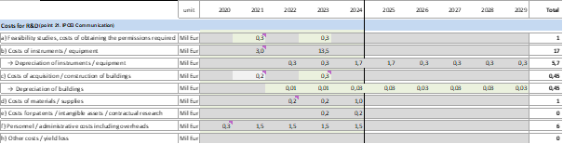

Table 15 R&D eligible costs

The FID eligible costs amount to 44 836 k€ (2024-2029) and they are distributed among the various cost categories according to the table below:

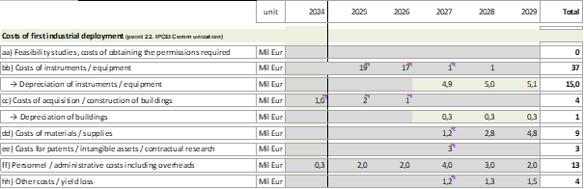

Table 16 FID eligible costs

Only the depreciation costs corresponding to the life of the project, as calculated on the basis of good accounting practice, are considered as eligible

* 1. State Aid

Without public funding, a positive NPV would not be met for Engie’s ElHyse project: there is a negative funding gap of -23,6 M€ with a post-tax discount rate of 8.3 % and 11,6% respectively for R&D phase and FID phase (see below chapter 6).

To compensate for the negative NPV of the project, the maximum required State aid from France is a nominal grant of 49,3M€. Total eligible costs amount to 58,5 M€. The State aid intensity would therefore amount to 84,3 % of eligible costs.

The anticipated instalments of the grant, when calculated as 84,3 % of the eligible costs every year, is shown in the following table:



Table 17 Anticipated instalments of the grant as a percentage of eligible costs every year

Based on these instalments, the pre-tax discounted value (at 8.3 %/11,6%) of the 49,3 M€ nominal grant amounts to 38,5M€ and its post-tax discounted value (at 8.3 %/11,6%) amounts to 10,9 M€: it is equal to the Funding gap.

1. Spill-over Effects

Different dissemination activities, ranging from awareness to exploitation, are proposed by Engie to ensure the translation of developments and outputs into new findings and market opportunities for third parties (research organisations, companies, Members States, industrial sectors). The objective is to reach the fullest range of potential users and uses among research, social, investment and policy makers. Engie developed a specific Work Package in the project’s global Work Plan for planning all dissemination actions (WP 6). These actions are targeted towards companies, research organisations that are not direct participants in the IPCEI on Hydrogen, towards Member States that are not supporting the IPCEI on Hydrogen and towards industrial sectors that are not represented in the IPCEI on Hydrogen.

* 1. Spill-over by non-protected results diffusion

Engie commits to open up its Cryogenic test platform which will result from the Elhyse project. Third-party access to European companies from other sectors (microprocessors, etc.) will be granted at market price on a transparent and non-discriminatory basis. This will improve knowledge in other sectors e.g. on materials resistance at very low temperatures.

The project will have a very high scientific content and as such, Engie will commit to diffusing these results. The content of the diffusion will be related to the R&D on a large liquid hydrogen production plant and method of diffusion will be through publication in European scientific journals.

Engie also commits to create an on-site event at least 2 “journée portes ouvertes” per year to explain the liquid H2 production chain and ship refuelling system. Target audience could be ports / local authorities / shipowners / airports / train companies and green mobility foundations.

For a less business audience Engie also commits to developing various communication tools to explain green mobility initiatives aimed at ships which are based on hydrogen. The target audience would be schools, professional forums and conferences. To achieve this communication task Engie would create videos, photos infographics, etc.

* 1. Spill-over by IP protected results diffusion

The IPCEI on Hydrogen is about the development of a complete European supply chain for low CO2 hydrogen technologies and applications. Many IPCEI partners will develop technological building blocks to develop this European supply chain. Some of them will be IP protected typically through filing patents. Engie is committed to develop Intellectual Property (IP) such as patents. IP creation will range from process technology, general architecture, software, and hardware development.

Regarding the exploitation of IP-protected results, only a very low number of exclusive IP licenses deriving from the IPCEI on Hydrogen results are expected. Indeed, the patents that will be licensed will be related mainly to generic technological building blocks; therefore, they will not be blocking for the final products or processes because alternative processes and solutions could be implemented. This will actually serve to create further innovation in Europe as wider industry takes the building blocks and then develop their own products and processes.

Moreover, dissemination policies will be implemented in order to promote and stimulate new approaches regarding the licensing of generic IP building block (avoiding any blocking issues for final product), with a view to serve other application fields through different value chains in order to get wider societal impacts (e.g. in the microelectronics sector, etc.). The IP will be generated with the intent to be as open as possible in order to facilitate the best possible uptake of new technologies from the IPCEI on Hydrogen.

Engie expects to file 10 patents on results from Elhyse during 2031-2040 period of time, regarding the following technological building blocks:

* Liquefaction cycle
* Integration of the LH2 production to the global LH2 supply chain.

Intellectual property rights on Elhyse’s results will be shared with Engie’s partner in this endeavour: Ariane Group. Engie’s IP strategy will also allow for the cross-industrial use of its IP protected results from the IPCEI on Hydrogen. More specifically, Engie’s commits to grant FRAND licences on its IP-protected results to…

* 1. Spill-over in the FID phase

Within the project timeframe, FID activities in the IPCEI on Hydrogen will lead to significant spill-over effects in downstream and upstream markets, among IPCEI partners but most importantly also beyond them. In general words, downstream and upstream markets parties will benefit in many ways from the FID phase. The IPCEI on Hydrogen will enable them to develop new equipment / instruments, new methodologies, new product applications and designs and to acquire specific skills as well as knowhow, which again can be used in cooperation with third parties (inside and outside the IPCEI).

A key asset of the IPCEI on Hydrogen is to embed many players from all across the hydrogen strategic value chain, either as direct or indirect participant. Additional cooperation programs will bring even more players inside and outside the Member States which fund the IPCEI. This is a strategic advantage that will make easier access to them inside the European Union. Engie’s strong implantation in France and in Europe (for example ENGIE Lab CRIGEN in France, and LABORELEC in Belgium) generally speaking will attract many actors such as research labs, SMEs, start-ups… in the context of innovation proposals around provision of hydrogen-based sustainable energy solutions.

In the IPCEI on Hydrogen, Engie will provide access to next generation liquefaction technology as well as to new technologies issued from the FID phase to partners, large companies, SMEs and PROs. This will be very helpful for SMEs and PROs (e.g. as listed in the Chapeau document as direct or indirect partner in all Work streams and for example Fives) which want to develop new applications considering the innovative liquid hydrogen full supply chain. These partners will benefit of an early access to the latest engineering methods and the most innovative testing equipment. This will empower them to shorten their development time.

Downstream market players (those related to mobility applications of liquid hydrogen but also industrial applications) tend to be the main contributors initiating new requirements for innovative liquid-hydrogen based solutions: new designs, new technologies, new testing equipment, new supply chains. Once the need is known by a potential customer, through market studies or direct market request, a feasibility study is launched. Eventually, a decision is made in order to start R&D&I work. But during the R&D&I phase, the new methods / technologies / testing equipment / supply chains are not reliable enough. The downstream market is usually not interested to test such innovations at this stage.

Conversely, when entering the FID phase, the innovative methods / technologies / testing equipment / supply chains have demonstrated their intrinsic value: functionality, reliability and a minimum level of repeatability. At this point, some engineering methods / technologies / testing equipment / supply chains can be translated to downstream markets. Sampling with demonstrators, while sharing the costs and risks between the potential end user and the technology provider, can start and continuously involve R&D&I phase in downstream markets: mock-up conception, measurement and testing campaign, additional specification request, data gathering and processing, several generations of prototyping, reliability at application level, are some examples of typical R&D&I activities of downstream market partners.

The FID activities from the liquid hydrogen supplier and the R&D&I or FID from the downstream markets progress in the same time. This is a decisive phase to assess the new technologies and make the downstream markets ready to use them. A successful final stage is when downstream markets initiate their own FID while using the innovative technologies in the first deployed liquid hydrogen supply. Engie and CMA CGM plan to work in such a collaborative framework, thanks to the French public support. But other users will be able to embark upon these dynamic processes with Engie, including outside the targeted sector (maritime transport).

The FID phase will also generate spill-over effects to other industrial partners such as equipment / instruments manufacturers present all over Europe. Indeed, in order to support the FID phase, some technological progress will be needed from these industries for many pieces of equipment: compressors, turbine expenders, chillers, vessels, re-condensers, etc..

Thus, the benefits of the FID phase are clearly not limited to the company itself but will also spill-over to the project’s partners and further expand to many EU high-tech industries, businesses and research organisations. IPCEI on Hydrogen will create positive spill-over effects on multiple levels of the value chain.

More specifically, Engie…

In order to inform the European technological and scientific community about this new opportunity, the company commits to communicate through press releases, media tools and during workshops about the inauguration of the new manufacturing facility, as well as to actively approach at least 10 European SMEs and PROs from non-IPCEI Member States each year to check whether they could be interested.

1. Other positive effect on the market
   1. Impact of the Project on Employment and New Investments in Europe

According to an AFHYPAC study, hydrogen could represent 20% of energy demand in France in 2050, and could generate a turnover of 40 billion euros and more than 150,000 jobs.

* 1. Environmental protection and reduction in energy dependence

Today, over 50 percent of the global production of hydrogen is used to produce ammonia for urea and other fertilizers. Of the remaining half, around 30 percent is used for various processes related to refineries and about ten percent is used for methanol production. Hydrogen for transporting purposes is merely a marginal market as of today. In total the current demand for hydrogen is about 8 EJ of energy per year, equivalent to about 67 million tons of hydrogen or 2224 TWh of electricity

The future global hydrogen market is dependent on both technological and political development. The International Renewable Energy Agency (IRENA) estimates an additional market demand of 8 EJ in 2050 – in addition to the current demand in feedstock. The growth will come in the transportation sector.

In a more optimistic scenario, the Hydrogen Council foresees that the hydrogen market could increase tenfold to 78 EJ in 2050. While all sectors grow, transportation makes the largest leap, from next to nothing in 2019 to approximately 22 EJ or 6116 TWh of electricity.

The transport sector is highly dependent on fossil fuels and alone accounts for more than 20% of global CO2 emissions worldwide. Maritime transport accounts for 3% of these emissions and the air transport represents 11% of these emissions. Petroleum products are overwhelmingly (90%) used for mobility. However, the authorities impose more and more ambitious roadmap for a full decarbonisation of the maritime transport sector. Here are some examples: the International Maritime Organisation (IMO) has recently made important decisions with regard to the increase of the GHG emissions from ships. ***IMO has set a 50% reduction target for emissions related to maritime transport by 2050 compared to 2008.*** In France, the government announced in June 2020 its willingness to develop a full decarbonized hydrogen plane by 2035. At the same time, SNCF indicated that all diesel trains will be replaced by hydrogen trains by 2030.

Those decisions pushed the transport industrial actors to look for solutions to use sustainable energy sources and lower harmful emissions. In June 2020, CMA CGM committed for a more balanced globalization, which contributes to Economic and Social development, whilst respecting humanity and protecting the planet. CMA CGM announced at this occasion that their energy supplies will include 10% alternative fuels by 2023 and their 2050 objective is to be Carbon Neutral.

Hydrogen fuel, if produced from renewables, is a promising zero-emission solution drastically reducing CO2 emissions in comparison to heavy fuel oil (see figure below) eliminating NOx, SOx and Particulate Matter emissions.



Figure 21 - CO2 emissions of fuel alternatives

Adapted to any type of transport, hydrogen presents itself as a promising substitute for petroleum which could accelerate the decarbonation of transport, provided that it becomes economically competitive.

Hydrogen has a high specific energy in joule or kWh/kg, but a low energy density compared to other fuels for heavy-duty and long-haul mobility (ships, barges, planes...). At lower heating value it contains 120 MJ/kg or 33.3 kWh/ kg and has a density of 0.08 kg/m3 in gaseous form at a pressure of 1 bar and 70.8 kg/m3 in liquid form. By reducing the temperature of the hydrogen to – 253 degrees Celcius it converts to liquid form, which is a more suitable for distribution of large quantities. LH2 at 0,1 MPa (1 bar) contains about four times the energy per volume unit than does compressed hydrogen at 25MPa’s (250 bar) and almost three times as much than for 35 MPa’s (350 bar).

Liquid hydrogen (LH2) having a higher volumetric energy density offers an alternative for heavy and long haul mobility (ships, plane) but there is no technical solution available at acceptable costs.



Figure 22 - Fuel energetic density comparison

The objective of the project is to develop a technical solution reducing drastically the cost of hydrogen liquefaction

The development of this liquefaction technology will accelerate the decarbonization of heavy and long distance transport: maritime and river but also road, rail, air.

Liquefied hydrogen provides a solution to the specific storage and autonomy constraints of these sectors.

Regarding road transport, the distribution of renewable liquid hydrogen for heavy goods vehicles will allow ENGIE to complete its alternative multi-fuel offer (electric charging stations, gaseous and liquid hydrogen) within its network of NGV stations - as presented in the Rhyzomes project - and thus propose the zero-emission alternative best suited to the type of vehicle (light to heavy) and to use (occasional to intensive)

* 1. Market failures: coordination problems
     1. Coordination failures between companies and research organizations

The very large number of public and private initiatives to define a mainstream trend to develop the next generation of hydrogen technologies creates important coordination problems. Academia and businesses differ greatly in many aspects. The goal of scientists’ activities is the growth of knowledge, while for companies the principal motivation is profits. Each one tends to underestimate or even discard the objective that the other pursues. Reward modes are also orthogonal: an important scientific discovery will contribute to the reputation of the team that makes it, while a significant innovation will enrich the company that develops it. Finally, scientific results acquire their value when they are shared through scientific publications, while businesses’ R&D&I results get their value if they are patented. The reconciliation of the two approaches is possible but often causes misunderstandings and conflicts.

The goals of research organizations and companies are often disconnected. The main reason is due to the time horizon under consideration. While research organizations are often concerned with plausible long-term trajectories, companies are oriented towards projects that can have clear value added in the short term. This causes a large disconnect between the kind of research that is done by research institutions and the kind of research that firms need to make profits. In simpler terms, research organizations are often concerned about possible paths the economy could take, whilst companies are concerned more about which paths are more “effective” in terms of direct economic benefits.

The difficulties that companies and research organizations face when trying to work together are well documented. In particular, these relations are known to be much more complicated in Europe than in the United States. A lack of investment by public and private actors inhibits knowledge transfer by directly limiting the transfer capacity between public research organizations and companies, leading to limited communication and increases in coordination failures. This lower investment could be attributable to a stricter dichotomy in Europe between public and private financing.

In the case of the European hydrogen strategic value chain, this lack of coordination between research organizations and companies in most Member States is a major systemic failure. Its outcome is a deficit of growth and competitiveness as compared to other parts of the world, particularly Japan and the United States. This is reflected in the loss of momentum of European players in research and innovation capacity, particularly visible in the low impact of their patents worldwide.

In addition, partnerships between research organizations and companies tend to be set up only at a local dimension. Given the cultural gap identified above, they prefer to collaborate when they know each other well and are close, which leads to neglecting other partnership opportunities that could be more productive from the scientific and technological points of view. The lack of cross-frontier public funding leads some public research organizations to focus solely on local companies for partnerships. This means that there could be potential synergies that could be exploited at the more European level in the form of cooperative projects if far-reaching connections were facilitated.

The IPCEI on Hydrogen will promote an intense cooperation between academic partners and industrial partners from many Member States. Market forces alone cannot lead to such cooperation. This major European R&D&I and industrial partnership will significantly intensify scientific and technological exchanges between European players from academia and from players across the industrial value chain. As part of the IPCEI on Hydrogen, the research agendas of academic laboratories and companies will be better aligned, and exchanges will transcend the borders established by local tropisms. Thus, the ambition of R&D&I activities can be of a higher level. The IPCEI on Hydrogen initiative will foster new trans-border collaborations between EU companies. Without the IPCEI on Hydrogen, such collaboration would very likely not have happened.

* + 1. Coordination failures between European research organizations themselves

Most European research organizations suffer from sub-critical size to engage in advanced research in next generation hydrogen technologies. Such research activities require heavy resources in manufacturing equipment, testing and characterization. No European public research laboratories own the full set of equipment included a complete pilot line to carry out their research activities.

The sub-critical size of European research organizations, combined with a lack of coordination between them, leads to dispersion and redundancy. Important efforts are made on some research topics without exchange of information, leading to a deteriorated scientific productivity, while other topics are neglected. The setting up of in-depth discussions within each field of next generation hydrogen technologies can enable knowledge production to be more efficient.

The IPCEI on Hydrogen will mobilize and bring together many European research laboratories, thus making it possible to overcome the lack of coordination that characterizes them. As part of the project, the redundancies will be removed, synergies and exchanges will be developed to pursue common R&D&I objectives in the field of advanced technologies for hydrogen, considered to be strategic for Europe.

* + 1. Coordination failures between SMEs and industry leaders

The IPCEI on Hydrogen will provide SMEs with access to R&D&I activities and innovative infrastructure that they would not have accessed in the absence of the project. Without State aid, ENGIE would work with some of these SMEs in a standard "client-supplier" logic, rather than associate them as partners and allow them to anticipate technological breakthroughs. Thus, most of these SMEs simply would not have the ability to work on these highly challenging technological areas.

The State aid encourages many European SMEs to collaborate and invest in R&D&I, by pooling and sharing risks. The project will enable the actors to achieve collectively the critical size that is needed to carry out advanced hydrogen R&D&I activities. European SMEs in the hydrogen sector will coordinate R&D&I activities with much higher levels of ambition and risk, and they will be offered the opportunity to access the expensive pilot facilities that will be developed by industry leaders such as ENGIE.

* + 1. Coordination failures between European clusters

The European hydrogen industrial value chain is limited in size and scope because of the market’s infancy and lack of business / technological opportunities. It is insufficiently coordinated to foster complementarities, synergies, economies of scale and learning curves that are key in order to bring the low-carbon hydrogen costs down and compete globally. The weakness of cross-frontier public funding for large projects leads each cluster’s actors to carry out their R&D&I activities in a regional logic, e.g. at a level of a city that wants to purchase a dozen hydrogen buses with the associated hydrogen infrastructure. The weakness of cooperation between European clusters leads to redundancies, neglecting synergies and significant complementarities, and finally to significant losses in terms of scientific and technological productivity.

Addressing in a coordinated manner the many scientific, technological and industrial objectives of the IPCEI on Hydrogen constitute a major organizational challenge, particularly for the development of new technology platforms, pilot facilities and large-scale roll-out projects. All players across the European industrial value chain must engage in closely coordinated R&D&I, FID activities and environmental / energy / transports projects to achieve this development, reducing redundancies, developing synergies and complementarities. Only a very large collaborative project supported by several Member States can achieve this.

* + 1. Coordination failures of a very large-scale R&D project

The great scope, scale and the high scientific and technological complexity level of the IPCEI on Hydrogen require joint work amongst a very large number of actors, most of them industrial companies and some being public research organizations and university laboratories.

The intensity of collaboration inside IPCEI on Hydrogen is very important, program partners will work in a very strong interdisciplinary and intersectoral sense, which could not be mobilized without the State aid. The results obtained by each partner will impact the other partners' actions. The collaboration must be coordinated in a very close and dynamic way, in order to get the best results from trials and error experiences of R&D&I, FID activities and environmental / energy / transports projects, as well as to reorient all work packages as a result of the progress of each partner, so that the R&D&I, FID and EET program can achieve its common European objectives. Round trips will be necessary between the different partners to coordinate their work, in order to remove the technological barriers that will be identified. This is a huge task.

State aid to partners of the IPCEI on Hydrogen deeply strengthens the coordination of the consortium. The disbursement of the public funding will be spread over the lifetime of the project, thus necessitating a very close monitoring by public authorities through progress reports, milestones, etc. All partners know that they must move forward together towards the achievement of IPCEI on Hydrogen objectives to get the public funding. Thus, the State aid gives each partner very strong dynamic incentives to overcome the difficulties of such a highly ambitious, large-scale and long-lasting project. It makes possible to set up a very large European R&D and FID partnership which constitutes an efficient and responsive mode of organization, able to catalyse synergies between partners and ensure gathering and coordination of the broad spectrum of necessary sector skills for the realization of such an ambitious project. Major European players in the hydrogen sector will all work together for the first time in a collaborative approach around a major unifying R&D&I and industrial program, kick-starting the European hydrogen market, as well as lowering the technical and economic barriers.

* + 1. Coordination failures associated with contractual incompleteness

The State aid will also limit the coordination difficulties related to the contractual incompleteness of major collaborative R&D&I programs. It is well known that R&D&I contracts are incomplete, that is, they cannot anticipate or take into account all possible situations and all future contingencies. Indeed, R&D&I programs are characterized by high uncertainty: not all results can be determined in advance ("serendipity"), unanticipated scientific and technological hurdles can arise, with a potentially strong impact on the program's calendar or costs, successes or failures can come from where they were not expected, etc.

Contractual incompleteness may encourage opportunistic partners' behaviours, reducing their commitment to the collaborative R&D&I project. In such context, cooperation is rendered very unstable by the alternative opportunities that are offered to the partners. The occurrence of an unforeseen event in the contract can lead to a chain of reactions from the partners, putting at risk the primary purpose of the partnership. Naturally, this risk is all the more important as the number of partners grows and the research is of a high level of complexity, which is very clearly the case for the project IPCEI on Hydrogen.

A very large collaborative R&D&I project like IPCEI on Hydrogen is characterized by a high uncertainty, which means the occurrence of unpredictable events during the project. A partner could invoke the occurrence of an unforeseen contingency in the contract to defend opportunistically his interests. The collaboration contract cannot therefore prevent these behaviours. Sanctions or penalties cannot solve this problem: a sanction can only apply over a behaviour considered as deviant by reference to foreseeable configurations provided for in the contract.

Second, the interests of the partners may diverge over the content of the program, or its objectives, or even its costs, as it progresses. This is common in a very large collaborative R&D&I program like IPCEI on Hydrogen, since project developments are very likely to deviate from the initial plan. Therefore, each of the partners would tend to influence the program in such a way as to favour its interests to the detriment of the common interest of the consortium, while it would be hardly possible to invoke the contract to prevent it (in particular, through penalties provided for in the contract). This may for example involve renegotiating the allocation of costs between the partners, to the detriment of the effectiveness of the project.

Third, it is very difficult, if not impossible, to anticipate and define in an exhaustive way the totality of the results of a very large R&D&I program. Thus, one of the partners might be tempted to appropriate some unanticipated results of the program by claiming that they would result from R&D&I activity outside the program. Here again, applying fines could not address anything, because of the intrinsic uncertainty of the very large collaborative R&D&I programs and the resulting contractual incompleteness.

The examples above, where a partner might be interested in adopting opportunistic behaviour, are not exhaustive. However, they provide an overview of the wide range of opportunities for partners in a very large collaborative R&D&I program like the IPCEI on Hydrogen to derive a profit from the program at the expense of the common interest of the partners. Thus, although collaborative R&D&I contracts are essential for framing partnership relations, they may reveal a limited effectiveness in managing the divergences of interests that do not fail to appear, especially in the context of a program as expensive, long and complex as the IPCEI on Hydrogen. Since it is very difficult to anticipate all situations in which a partner might have an interest in opportunistic behaviour, or even to prove this type of behaviour, it is impossible to provide for an appropriate system of sanctions.

State aid makes it possible to reduce a priori the opportunistic behaviour that may result from contractual incompleteness, and thus facilitates the coordination of IPCEI on Hydrogen partners. Indeed, for each partner, the risk related to the implementation of the program will be shared with the public authorities, limiting its potential financial losses in case of failure. This sharing of risks reduces each partner's incentives to use opportunistically contractual incompleteness to his advantage.

* 1. Market failure: Imperfect and asymmetric information
     1. Risks affecting the project
        1. Technological risk

The European Commission generally recognizes that a greater technicality of a R&D project goes along with a greater probability of failure. R&D and innovation are highly complex and challenging in the hydrogen sector, and therefore they inherently carry a very high level of risk.

In the specific context of the ElHyse project, ENGIE will undertake RDI activities in order to explore scientific and technological paths that are very risky to develop a full supply chain for liquid hydrogen. The technological risks this represents has to do with developing and connecting technologies all across the supply chain from the liquefier to the ship, taking into account the potential variety of boats that will have to be fitted.

It is well understood that all these very innovative R&D and innovation pathways that will be explored as part of the IPCEI on Hydrogen may not be performing as anticipated. The technologies developed by ENGIE are characterized by a very high level of complexity and there is a high risk that the work undertaken in the project will not achieve all the expected results, or not in the anticipated planning. For each technical objective, there are indeed several paths that can be explored in parallel, and the paths chosen within the project may not produce the expected performances. Ultimately, the competitiveness of the liquefied hydrogen supply chain could be hampered.

Furthermore, there is a risk of non-compatibility of the solutions developed in the R&D phase when they go to the large-scale industrialization, or with the equipment available on the market. For example, …. High-performance technology may be difficult to exploit in order to produce operational finished products.

* + - 1. Economic risk

Different learning curves for different competing technologies for hydrogen production will develop as a consequence of market expansion in the coming decade. There is a risk that not only ENGIE technologies be introduced too late on the market but also that the cost of competing technologies decreases quicker than the cost of ENGIE’s technologies, entailing a significant economic risk is attached to the innovative application of the liquid hydrogen supply chain.

* + - 1. Partnership risk

The risk of partnership of a very large R&D and industrial program such as the IPCEI on Hydrogen results from the difficulties to organize the coordination and the synergies between such a large number of actors and centres of competences that are culturally very different, as well as to maintain the cohesion of the partnership in the long run.

The R&D and industrial partnership set up in the IPCEI on Hydrogen involves a very large number of partners coming from various sectors; they also have different sizes and institutional origins. Indeed, the IPCEI on Hydrogen requires academic research laboratories and companies to work together on common scientific and technological objectives. Given the strong interdependence between their activities, it will be very difficult to coordinate their numerous contributions to the project. It is clearly the case regarding the contributions of the numerous public research laboratories, which will work in parallel on multiple tasks of scientific modelling and development of basic technological building block. The same applies to SMEs that will embark upon the task of developing innovation on very specific components that will have to be integrated in a complex supply chain.

Lastly, Elhyse is a project which involves patent agreements between ENGIE and its partners. They need to be closely involved to ensure that permissions of exploitation from their shared projects are well drawn out for a large variety of contingencies.

* + - 1. Risk associated with major R&D programs

Major R&D and industrial programs such as IPCEI on Hydrogen, which extend over several years and aim at many technological breakthroughs across complementary steps in the low-carbon hydrogen value chain, are generally exposed to numerous and significant risks that are not all identified and even less quantified. For example, it is common for nominal objectives not to be achieved. Also, there may be defects at the interfaces, delays in the availability of the results of a subsystem, failures of partners during the program, technical and functional problems, etc. This is why significant uncertainty often weighs on the fulfilment of the initial schedule, as well as on the forecasted estimation of R&D and industrial expenditures. The two risks are associated to the extent that each year of delay generally induces significant additional costs.

* + - 1. Regulatory risk

There are already some existing regulations on land hydrogen infrastructure, but not on the maritime side. Pre-normative discussions are underway, but in the meanwhile, onboard developments take place under an exemption regime, which is burdensome for shipowners. This could delay or lower the ambitions for the adoption of hydrogen-based solutions on the ships.

* + - 1. Strategic and organizational risk

There is a strategic and financial risk in relation to the strong signal that ENGIE gives to the financial markets with its participation in a large program like IPCEI on Hydrogen. Indeed, the financial markets favour a perspective of short-term profitability rather than a longer-term industrial vision. Therefore, for a company like ENGIE, financial analysts favour criteria such as the optimization of the gross margin and the operating margin. They would even favour a rebalancing of the cost structure in order to limit exposure to the euro / dollar exchange rate. Likewise, the risk for Europe of not being able to ensure its strategic independence in these advanced technologies is not considered in their analysis.

All these elements plead in favour of a reduction in ENGIE’s long-term spending in return of the company taking risks to prepare for the future, which goes precisely along with a project such as ElHyse that is addressing the long-term challenge of carbon neutral maritime transport. Therefore, when committing itself to a project as large as IPCEI on Hydrogen, ENGIE faces the risk of a deterioration in its appreciation on the financial markets. As one of the leading partners in developing the hydrogen mobility market this should be avoided and supported by IPCEI on Hydrogen.

* + 1. Market failure: Difficulty to recruit highly qualified personnel

At the global level, the hydrogen sector suffers from an important difficulty for the recruitment of highly qualified profiles, a problem that hinders the development and commercialization of innovative technologies due to its low maturity. This shortage is a result of mismatches between needed skills and available skills on the labour market. The qualifications proposed by the education system, university formations or training programs lag behind the fast-changing specific highly qualified profiles required in the hydrogen sector.

One key problem is that training programs fail to include several scientific disciplines under one technological field, while companies in the hydrogen sector are demanding profiles with strong interdisciplinary skills. As explained in Bezdek (2019),[4] many of these jobs do not currently exist and do not have occupational titles defined in official classifications. In addition, many of these jobs require different skills and education than current jobs.

One of the main objectives of the public support for the IPCEI on Hydrogen is precisely to foster university – industry collaboration and to enhance the attractiveness of the European hydrogen clusters regarding the highly qualified labour market, thus supporting the evolution of academia to train and supply to the market these highly qualified profiles. For that purpose, thanks to public funding, the IPCEI on Hydrogen will implement the following features at a very large European level: a strengthening of partnerships, a better circulation of ideas and people and a better mutual understanding between public research organizations and companies.

The specific technical skills that are needed are numerous, from engineers specializing in electrical equipment, to software specialists who can automate the processes, to station designers and who will ensure optimized equipment. There is also a significant innovative component which must be carefully calibrated theoretically by specialists in electrical product development. The IPCEI on Hydrogen will contribute to a better classification of the wide variety of the required jobs in the low-carbon hydrogen industry.

* + 1. Strategic independence of supply

Europe is strongly dependent on imports of energy, including natural gas and petroleum products. These are the products that are used nowadays by the shipping transport sector. Hydrogen is barely used for mobility applications as of today (see **Erreur ! Source du renvoi introuvable.** below). ENGIE’s ElHyse project will develop and first industrialise an innovative liquid hydrogen supply chain for ships. The purpose is to increase the relative competitiveness of low-carbon hydrogen to existing fuels, natural gas and petroleum products. The hydrogen will mostly be sourced from Europe itself, and as such, in case of success and diffusion of this technology Europe-wide, it will result in less dependence on European imports of natural gas and petroleum products.

* 1. Adequacy of the state aid instrument
     1. Appropriateness among alternative policy instruments

There is no other less distortive policy instrument than State aid which would make it possible to achieve the same result for the IPCEI on Hydrogen.

* + - 1. The regulation

Regulation is a standard and widely used public policy instrument. The use of regulation to implement the IPCEI on Hydrogen has little practical consistency. In theory only, Member States could impose to companies in the industry to develop the innovations proposed in the IPCEI on Hydrogen, based on full technical specifications. However, because of the numerous technological uncertainties weighing on the technological building blocks and integrated systems to be developed, such regulation does not seem to be realistic. For example, it is very likely that due to deficient information from the State regarding the evolution of the hydrogen market, regarding the technological state of the art, regarding the strategies of the different actors, etc., the choice to impose the development of such an innovation rather than another would be inefficient.

It is much more efficient to trust the strategies and technological choices of companies to decide on their R&D and industrial projects. This is the option retained in the IPCEI on Hydrogen.

* + - 1. A better funding of public research

The IPCEI on Hydrogen aims at removing technological barriers and demonstrating the technical and economic viability of many industrial innovations in the field of hydrogen. The project must therefore have a strong technological and industrial component, on top of its scientific dimension. To this end, R&D activities must be carried out simultaneously in public research organisations (which will contribute, with their advanced knowledge, to the development of scientific models) and in companies, which have the essential role to ensure the development of new technologies and their industrial and commercial deployment. For this specific purpose, the environmental / energy / transports projects that are funded in the IPCEI on Hydrogen play a major role as they enable early and large-scale implementation and roll-out of the innovative technologies. A very important gap (in terms of time, cost, and risk) separates the concepts studied in PROs from the demonstration of the technico-economic viability of an innovation, carried out in companies.

A better funding of public research would not achieve the same effect as the State aid from France for the IPCEI on Hydrogen, meaning the structuration of a sustainable ecosystem of research and innovation and roll-out around a very large R&D and industrial partnership between many public and private actors from numerous EU Member States.

* + - 1. The research tax credit

In order to succeed, the project IPCEI on Hydrogen must implement a strong collaborative logic between multiple public and private European actors.

A general tax measure in favor of R&D, such as the research tax credit (Crédit Impôt Recherche in French) implemented since 2008 by the French government, may lead French companies to boost their individual R&D efforts. However, it is not oriented towards the deployment of the European collaborative logic of the project that is a necessary condition for its success.

Moreover, there are strong complementarities in the IPCEI on Hydrogen between R&D / FID activities on the one hand, and environmental / energy / transport projects on the other hand. The former develop and supply innovative hydrogen technologies while the latter enable early and large-scale implementation and roll-out of these innovative technologies. Supporting one leg (R&D) with the research tax credit without the other (EET) would not unlock the development of the low-carbon hydrogen market.

* + - 1. The innovation tax credit

The innovation tax credit is a French tax measure reserved for SMEs to stimulate their innovation activities, such as building a prototype or a pilot installation of a new product. In concrete terms, a SME having incurred innovation expenses of up to € 400,000 will be able to receive a 20 % reduction in the cost of the expenses incurred in favour of the innovation.

The IPCEI on Hydrogen is dependent on the complementary contributions of a very large number of partners: large companies, SMEs and public research organizations, in France but also in several other Member States. All contributors that are not SMEs nor French cannot benefit from the French innovation tax credit. Conversely, the IPCEI on Hydrogen cannot start based only on the contributions of French SMEs that would be supported by the innovation tax credit. Therefore, this fiscal measure is not an appropriate policy instruments to promote the large R&D and industrial collaboration envisioned in the IPCEI on Hydrogen.

Moreover, some key partners, including Engie, are not SMEs and will have expenditures far above the 400,000 euros ceiling of the innovation tax credit. This is another reason why this fiscal measure does not constitute an appropriate policy instrument to promote the activities carried out in the IPCEI on Hydrogen.

* + 1. Appropriateness among different State aid instruments

In the context of the IPCEI on Hydrogen, the main market and systemic failures come from spillovers, huge coordination problems and Europe’s strategic dependence on fossil fuels and industrial inputs. To address these failures, a grant is the most appropriate State aid instrument.

The market failure or other important systemic failure which the State aids aim to address are neither a problem of access to finance nor a problem of risk sharing. As such, a public soft loan, a State guarantee or a repayable advance are not taken into account.

The grant is intended to compensate for the low profitability of the project for ENGIE without State aid, induced notably by the very high level of spillovers (see Chapter 3). ENGIE understands that committing to disseminate the results of the project is a requirement for its activities to be eligible to State aid funding in the IPCEI framework. This being said, it remains that such spillovers result in a lack of incentives to invest in the project (they come with high costs but almost no income) and this is partly contributing to the negative NPV for the project. It is well known in economic theory that such positive externality has to be corrected by granting a so-called Pigouvian subsidy to the economic agent who is at the origin of the externality. This refers here to ENGIE who will carry out R&D and FID activities that will largely benefit to third parties as a result of the company’s commitments to disseminate the project’s results.

The simulation of a repayable advance in the business plan can only have a marginal impact on the project’s profitability: public money is received in the first hand but reimbursed including interests in the nominal scenario of success. Only a direct grant has the potential to have the profitability reach the company’s hurdle rate by filling the funding gap.

The grant also addresses the huge coordination problems (see Section 4.3), being a cement of the coordination of the partnership. The grant will encourage partners to commit to the project although it is exposed to a high degree of uncertainty and to returns that will materialize only in the long term. Indeed, the payment of the grant, spread over the 9.5 years of the project (mid-2020-2029) and closely monitored by French public authorities (progress reports, key milestones, decision-making milestones), offers dynamic incentives for the partners (including ENGIE) to overcome the difficulties of coordinating the very large research partnership, and to progress together towards the achievement of the project objectives.

The payment of the grant also limits the potential financial losses of the partners in case of project failure, which reduces their incentives to opportunistically use contractual incompleteness to their advantage. Repayable advances have a major drawback in this respect: they provide an additional incentive to opportunistically use contractual incompleteness, since putting the project in a situation of failure from the contractual point of view makes it possible to avoid repayment of the advance (while the project could be a success from the technical and commercial point of view). The grant to ENGIE is therefore the appropriate aid instrument to address the huge coordination problems in IPCEI on Hydrogen.

The IPCEI on Hydrogen is designed to bring together public and private sectors to undertake a very large-scale project that provides large benefits to the Union and its citizens. It is very clear that the huge coordination challenge rooted in the IPCEI on Hydrogen could not be addressed by providing a public soft loan, a State guarantee or a repayable advance to the IPCEI’s partners. Only a direct grant can adequately address such market or systemic failure.

However, the grant provided by France to ENGIE could be backed upon a claw-back mechanism that shall be targeted on the FID activities and related costs / State aid (they are closest to the market). The principles of this claw back mechanism will be considered and developed in the Chapeau text of the IPCEI on Hydrogen.

1. Incentive effect
2. **Absence of similar projects**

ENGIE has not studied any alternative projects to develop a liquified H2 value chain.

1. **Start date of the project**

The project has not started yet. The project will be launched from July 2020.

1. **Counterfactual scenario**

If no state aid, ENGIE would not consider R&D on liquid H2.

* In the past 3 years, ENGIE Lab has worked on XX projects relating to gaseous H2, (project to be detailed).
* No projects on liquid h2 so far. To this day, ENGIE did not consider liquid H2 in the scope of it’s R&D activities. ENGIE’s research center has some market watch on the liquid H2 sector, the application of liquid H2 being of increasing interest to the maritime sector, under the pressure of regulation on green mobility.
* Existing techno on the market (only Linde techno) can be optimised. Current techno is not optimised, and leads to high prices of liquid H2. The prohibitive price of liquid H2 did not trigger sufficient interest in the maritime sector (transport industrial actorss) which has not considered yet investing in r&d to convert their ships to liquid H2.
* Thanks to IPCEI, ENGIE and it’s partner Ariane will optimise liquid R&D value chain and offer maritime sector, partner CMA-CGM in the Elhyse project, liquid H2 at a price level that is considered compatible with the companies economic constraints.

1. **Increase in R&D and FID efforts**

*Explain and quantify the increase in R&D and FID efforts that are triggered by the State aid (in terms of size, scope, speed, risk, collaborations, etc.).*

IPCEI will finance part of R&D phase and as this is first of kind project, the IPCEI will not be profitable

|  |  |  |  |  |  |  |  |  |  |  |  |  |  |  |  |  |  |  |  |  |
| --- | --- | --- | --- | --- | --- | --- | --- | --- | --- | --- | --- | --- | --- | --- | --- | --- | --- | --- | --- | --- |
| *Scope of the table = ENGIE* | | 2020  T0 Project | 2021 | 2022 | 2023 | | 2024 | | | 2025 | |  | 2026 | 2027 | | 2028 | 2029  End Project | | | |
|  | | | |  | |  | |  |  | |  | | |  |  |  | |  |  |  | |
| **IPCEI on Liquid Hydrogen** | EET headcount | 1 | 5 | 5 | 5 | | 6 | | | 7 | |  | 7 | 13 | | 10 | 7 | | | |
| EET investment (M€) |  | 3,5 |  | 14,1 | | 1 | | | 21 | |  | 18 | 1 | | 1 |  | | | |
| EET Investment / Turnover (%) |  |  |  |  | |  | | |  | |  |  |  | |  |  | | | |
| **Business as usual** | EET headcount | 1 | 2 | 2 | 2 | | 2 | | |  | |  | 2 | 2 | |  |  | | | |
| EET investment (M€) | 0.1 | 0.1 | 0.1 | 0.1 | | 0.1 | | | 0.1 | |  |  |  | |  |  | | | |
| EET Investment / Turnover (%) |  |  |  |  | |  | | |  | |  |  |  | |  |  | | | |

1. Elaboration on Terms of the Funding Gap Questionnaire
   1. Main hypothesis of the business plan

In order to assess the activities grouped under the IPCEI on Hydrogen, Engie built a business plan considering the incremental efforts and the incremental returns of the project.

Engie took into consideration the costs and revenues from 2020 until 2040 which corresponds to a cycle of these installations with the R&D, development adjustment of the first 10tpd unit, expected revenues of the sold technology to third parties over a reasonable period ot time and expected duration at commercial pace of the 10tpd before a major revamping.. Therefore, all the value of the investment is captured in the business plans.

The business plan models the activities that are required in order to develop and first deploy at the industrial scale a complete liquid hydrogen supply chain for ships (2020 to 2029) and further roll out such supply chain in several ports for dedicated customers. In a scenario of nominal success, the plateau of production is reached in 2030 and lasts for 11 years before the technology is the last volumes are produced in in 2041, and where discounted cash-flows are small.

The price of hydrogen is set at 8€/kg and decreases to 7€/kg after 2031 in order to reflect the market consensus of the cost to produce and distribute hydrogen for shipping applications. Therefore, external market studies have been used as a benchmark: among others, Hydrogen Council and McKinsey.

Engie standard periods of depreciation have been used: 10 years for equipment and 15 years for buildings. These durations are common in the industry. The terminal value was assessed using the net book value of the assets at 31 December 2040, which is null.

For the research and development phase, it will be a joint effort Engie and Ariane to develop a pilot and first adjustment of the 10tpd. The funding gap being Engie only therefore all the numbers are at 50%. For the first industrial demonstrator of 10 tpd of liquefied hydrogen, all flows are 100% and for Engie.

The WACC of Engie is used as the discount rate. It is equal to 8.3 % for R&D phase. For the industrialisation phase a discount rate of 11,6% takes into account the additional credit risk regarding the potential client.

The main material costs correspond to the 0,5 tpd pilot (3M€ for 50%equity) and for the first industrial demonstrator at 10 tpd, the liquefaction unit (27M€), the high capacity storage (15M€), the loading system (2M€) and the required equipment after operation adjustments (7M€). The project does not include off-site hydrogen production or the production of renewable energy.

The operating costs cover the green gaseous hydrogen, the renewables power consumption, the different cooling and inerting gases and the equipment maintenance.

Resulting from the successful demonstration of 10 tpd liquefaction unit with expected performance in 2030, 30 patents are expected to be sold during 2031-2040 period of time with a unit costs of 3M€ to be shared between Ariane and Engie.

Net working capital is based on the payment balance with one month delay between costs of supplies, personnel, other Opex and SGA on one hand and revenues from Sales and Grants on the other hand

Tax evaluation follows a tax rate of 25 % and accumulated tax credits resulting from negative EBIT in the beginning of the project are carried forward and charged against the positive income at a later stage.

The cash flows are discounted as of 30/07/2020, which should be the date of Engie’s decision to invest in the project, conditional on receiving strong public support from France.

The selling, general and administrative expenses are set at 2 % of the sales.

* 1. Necessity of state aid

According to point 28 of the IPCEI Communication, the aid must not subsidize the costs of a project that an undertaking would anyhow incur and must not compensate for the normal business risk of an economic activity.

The NPV of Elhyse is –23,6M€ without State aid, in a nominal scenario based on conservative and reasonable assumptions with -9,3 M€ discounted at 8,3 % for the R&D leg and –14,4 M€ discounted at 11,6 % for the FID leg This means that Engie Internal Rate of Return for this project is far below the company’s WACC (8.3%). Thus, it is clear that the State aid from France does not subsidize the costs of a project that Engie would anyhow have carried out.

* 1. Proportionality of state aid
     1. Firm’s hurdle rate

According to point 30 of the IPCEI Communication, in the absence of an alternative project, the Commission will verify that the aid amount does not exceed the minimum necessary for the aided project to be sufficiently profitable, for example by making possible to achieve an IRR corresponding to the firm’s hurdle rate.

Engie’ Internal Rate of Return for Elhyse taking into account a 49,3 M€ nominal grant from France is 10,2 %. This happens to be the weighted average of the company’s WACC (8,3%) for the R&D and company’s WACC with an additional risk of the potential client for the FID phase (11,6%). Thus, the required State aid would just provide the necessary incentive to enable Engie to launch these highly ambitious and long-term R&D and FID activities, by raising the IRR at the level of the WACC. The State aid does not confer extra profits for the company, it is proportionate.

* + 1. Project’s funding gap

According to point 31 of the IPCEI Communication, the maximum aid level will be determined with regards to the identified funding gap in relation to the eligible costs. The funding gap refers to the difference between the positive and negative cash flows over the lifetime of the investment, discounted to their current value on the basis of an appropriate discount factor reflecting the rate of return necessary for the beneficiary to carry out the project notably in view of the risks involved.

Engie funding gap for the IPCEI, calculated as the discounted difference between the positive and negative cash flows over the lifetime of the IPCEI on Hydrogen, amounts to -23,6 M€ (with a discount rate of 8.3 % equal to the company’s WACC for the R&D and 11,6% for the FID phase accounting for an additional risk of the potential client).

The State aid granted to Engie in France, in the form of a direct grant amounting to 49,3 M€ nominal, has a post-tax Net Present Value of 23,6 M€. Thus, it is exactly equal to the funding gap; the State aid is proportionate.

* + 1. State aid intensity

The eligible costs to carry out the proposed activities are calculated only to the level necessary for achieving the project objectives. They consist in feasibility studies, personnel costs and equipment / building costs the details of which are provided in section 1.8. For equipment and buildings, the Capex have been considered as eligible (see section **Erreur ! Source du renvoi introuvable.** above).

The total amount eligible costs amount to 55,8 M€.

Thus, the required grant (49,3M€) is limited to 84,3% of the eligible costs, which is far below the threshold of 100 % set by point 31 of the IPCEI Communication.

* + 1. State aid cumulation

In the light of the beneficiary's declarations and to the knowledge of the French authorities, Engie does not receive any State aid other than that indicated in point 2.2 of this notification to finance its share of work under the IPCEI on Hydrogen.

* + 1. Open selection proceeding

The first step of the selection of Engie as a partner for the IPCEI on Hydrogen and as a beneficiary of public support in France is the application to the open call for expression on interest launched on 27th January 2020; which is the purpose of this document. This call is based on objective criteria which are neither discretionary nor discriminatory. Many companies applied. This contributes to reinforcing the proportionate nature of the State aid.

1. Limitation of distortion of competition and trade

Work in progress

*Annexe 1:*

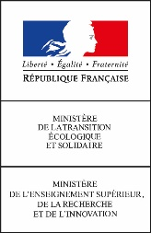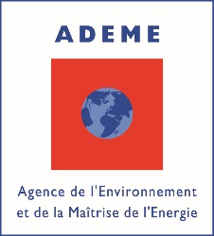

**A COALITION TO ACCELERATE THE ENERGY TRANSITION**

**OF THE MARITIME SECTOR**

***Coalition pour la transition éco-énergétique du maritime***

**CONTEXT**

**Situation**

Actually, there is no existing solution to achieve decarbonisation goals by 2050. The national and European ambition to reach carbon neutrality and the OMI’s ambition of 50% GHG emissions need technological and economic ruptures, especially for the new economic models and the new organisations of the logistic-mobility value chain.

Companies must invest now in new technologies compliant with the rules and social constraints from customers and citizens who demand massive reduction of carbon footprint and energy sobriety measures for products, services and leisure.

So, we have to connect the different strategies and roadmaps from the different parts of this logistic-mobility value chain because we share the same goals and we face the same challenges.

**A global systemic approach**

The Coalition considers that we need a cross industry approach between air-land-sea activities and the energy transition is linked with digital transformation. IoT, big data, digital twin, etc. will help stakeholders to monitor system, create energy models and collaborate threw new methods and tools.

So, the Coalition wants to achieve the **“0 Impact Ambition”**. International, European and national coalitions work actually on 0 emission vessels. Our goal is to work also on reducing the global carbon footprint, to reduce the negative externalities especially noise and waste associated to maritime activities. For this we need a global Vision on the whole of logistic-mobility value chain including shipping and port hubs and we will create a digital workplace for animating the common work and accelerating the projects.

**THE COALITION**

**Co-founders and partners**

The Coalition has been created by the French Maritime Cluster and the French Environment and Energy Management Agency. It was launched during the Assises de l’Economie de la Mer in December 2019 with the French President who asked the Coalition to present its first deliverables at the IUCN Congress in order to enhance and to increase the maritime commitment to the energy transition.

***Companies:*** Bureau Veritas | CMA CGM | Dassault Systèmes | EDF | Enedis | ENGIE | Naval Group | RTE | Soper | Total

***Federations:*** Association française pour l’Hydrogène et la Pile à combustible | Armateurs de France | Club Croisière de Marseille | Fédération française des Pilotes maritimes | France Filière Pêche | Groupement des Industries de Construction et Activités navales | Association française du Gaz – Plateforme GNL | Union française de l’Electricité | Union nationale des Industries de la Manutention portuaire | Union des Ports de France

***Research Centers:*** CEA | CNES | IFREMER | Météo France | SHOM

***Innovative Clusters :*** Pôle Mer Bretagne Atlantique & Pôle Mer Méditerranée

***Operating Partner:*** ECOSYS Group

**WORKSTREAMS & DELIVERABLES**

1. **Defining the energy models**

*Objective:* identifying the solutions – technological and non-technological – and defining the energy pathways by 2050. For this the coalition will work on concrete use cases for examples: containership, ferry, cruise, bulk, fishing vessel and equipment, port handling equipment and port industries, infrastructures and services.

Three interdependent elements make up these energy models:

* Energy mix and their technology
* Energy efficiency
* Ecological efficiency

*Deliverables*

* Shared CO2 and sobriety trajectories with methods and tools for validating the compliant technologies
* Global overview with a data base and mappings (actors, projects, technologies)
* Digital platform to facilitate collaboration and data sharing + developing the digital twin with energy models
* Roadmaps for techno by energy, including H2

1. **Animating the innovation ecosystem for energy transition**

*Objective*: consolidating a global innovation ecosystem to accelerate synergies between companies needs and solutions providers to create industrial projects and R&D programs in accordance with priorities defined in the workstream 1.

*Deliverables*:

* Creation of a “maritime energy transition” reference for connecting innovative incubators/accelerators in a cross-industry vision
* Creation of a SeaLab with a dedicated team and digital platform to boost the projects and animate the roadmaps

1. **Financing the energy transition**

Objective: working on the economic model of the energy transition solutions identified in the workstream1 and helping companies to be attractive for investors and to secure investments.

Deliverables:

* Mapping and analysis of the existing financing counters with a digital tool
* Creation of adapted financing measures

1. **Deploying the solutions for energy transition**

*Objective*: anticipating the rules and the services which must be adapted to the impacts of energy transition. The companies and consortium need to work in a secure and be encouraged thanks to incentives defined at world and European levels.

*Deliverables*:

* A lobbying strategy for the solutions identified
* Adapting the insurance policies to the energy transition solutions
* Defining a global plan for skills and training

***HYDROGEN***

The Cluster and the Coalition consider Hydrogen – and carbon-free hydrogen – as a key technology to reach the goal of decarbonisation.

In the first workstream “Energy Models” the Coalition will work on hydrogen based solutions for the different use cases selected by partners: containership, bulk, ferry, cruise, fishing vessel, port handling equipment, shore connection, in a cross-industry vision because we share objectives and technologies with other sectors and in a co-activity dimension because in port hubs there are a lot of activities looking at hydrogen based solutions.

The Coalition will define a roadmap based on these use cases to develop new technologies to implement hydrogen in maritime activities.

**Approach for Hydrogen**

* First of all, we have to identify specificities of each use case because they have different constraints (place, activities, geography, etc.)
* Second we have to analyze between 2020-2050 what does exist, what is possible, what would be possible and thus establishing a retro planning of hydrogen solutions in order to accelerate development of needed solutions and deployment of actual and future technologies to test and share experience.

**Main projects identified and main needs (+++):**

* Onshore
  + Hydrogen production: from renewables (wind, solar); fatal hydrogen
  + Hydrogen storage (liquid, solid, gas)
  + Uses: shore connection; mobility (trucks, vehicles, rail, barges, and tomorrow airplanes?); aerospace; etc.
* Offshore
  + Hydrogen production: from Marine Renewable Energies
  + Hydrogen storage
* Onboard
  + Propulsion: hydrogen gas turbine (+++); air independent propulsion,
  + Auxiliary: equipment (navigation, HVAC, living quarters, waste management, etc.); goods (especially reefers); 0 emission for coastlines maneuvers; etc.
  + Fuel cells: high power fuel cells (+++); synergies with other energies (methanol / or synthetic carbon-free fuels)

**Main obstacles identified:**

* Storage onboard for ships: storage energy density; security
* Economic model with hydrogen carbon-free comparing to oil or LNG
* Rules and incentives (especially tax law)
* Securing the investments (especially in the post-covid19 situation)
* Lack of data / rex sharing between projects and lack of industrial pilotes

So, **the maritime sector needs flArianeGrouphip projects** to consolidate the Hydrogen industry, to develop the technologies to produce, transport, store and use Hydrogen in the different activities especially for shipping, and also to secure investments and to adapt the rules. Energy transition needs Hydrogen, so Hydrogen needs also a transition from public stakeholders and traditional economic models. Thanks to multiple projects, the maritime sector will be able to cooperate with other industries and implement adapted solutions.

***FRENCH MARITIME CLUSTER***

*Headquartered in France, the French Maritime Cluster, is a professional organisation created in 2006 to accelerate synergies between actors sharing the same goals and facing the same challenges. The Cluster gathers 450 companies, R&D Centers, Academics and Territories from the whole of maritime activities, from industries and services.*

*The Cluster has Offices in Asia and connections all over the world threw a global network of companies and “Conseillers au Commerce extérieur” and has created Maritime Clusters in each Overseas Territories. The Cluster has also co-created the European Network of Maritime Clusters and contribute to its development with an agenda dedicated to blue growth and energy transition.*

1. Proposal for a Regulation of the European Parliament and of the Council establishing the framework for achieving climate neutrality and amending Regulation (EU) 2018/1999 (European Climate Law)
2. A New Industrial Strategy for Europe, COM(2020) 102; communication from the commission to the European Parliament, the European council, the Council, the European economic and social committee and the committee of the regions
3. Mobilité hydrogène France, proposition d’un plan de déploiement national des véhicules hydrogène.
4. Bezdek, (2019), „The hydrogen economy and jobs of the future“, *Renew. Energy Environ. Sustain*. 4, 1.